**Table of Contents**

Synopsis 1

Chapter 1: Introduction 5

**1.1.** **BACKGROUND:** 5

**1.2.** **OBJECTIVES:** 5

**1.3.** **PURPOSE, SCOPE AND APPLICABILITY** 5

**1.3.1.** **Purpose** 5

**1.3.2.** **Scope** 5

**1.3.3.** **Applicability** 6

Chapter 2: Survey Of Technologies 7

Chapter 3: Requirement Specification 13

**3.1. Problem Definition** 13

**3.2. Requirement Specification** 15

**3.2.1. Requirement Gathering** 15

**3.2.2. Requirement Analysis** 19

**3.3. Planning and Scheduling** 30

**3.4. Software and Hardware Requirement (Need)** 32

Chapter 4: System Design 33

**4.1. Business Rule** 33

**4.2. Module Diagram** 34

**4.3. Data Model** 37

**Flexibility of MongoDB Schema:** 37

**Approaches for Linking Related Data:** 37

**Reason for Selecting a Hybrid Approach in Mera Mann App:** 38

**4.4. Data Flow Diagram** 39

**4.4.1. Context Level DFD** 40

**4.4.2. Level 1 DFD** 40

**4.4.3. Level 2 DFD** 42

**4.5. Use Case Diagram** 46

**4.5.1. Use Case Diagram** 47

**4.5.1. Use case Description** 47

**4.6. Scenario** 51

**4.7. Sequence Diagram** 54

**4.8. Activity Diagram** 61

**4.9. User Interface Design** 63

**4.10. Test Case Design** 70

Chapter 5: Implementation and testing 75

**5.1. Implementation Approaches** 75

**5.2. Coding Details and Code Efficiency** 76

**5.3. Code Efficiency** 82

**5.4. Testing Approach** 84

**5.5. Unit Testing** 85

**5.5.1. Authentication Module** 85

**5.5.2. Mood Tracking Module** 86

**5.5.3. Meal Planning Module** 87

**5.5.4. User Management** 88

**5.5.5. Journal Module** 89

**5.5.6. Habit Tracker Module** 89

**5.5.7. Reminder System Module** 90

**5.5.8. Activity Tracking Module** 90

**5.5.9. Game Module** 91

**5.6. Integrated Testing** 91

**5.6.1. User Management - Profile Update and Fetch Integration** 92

**5.5.2. Authentication & Profile Update Integration** 93

**5.5.3. Mood Tracking & Profile Fetch Integration** 93

**5.5.4. Habit Tracker and stats Integration** 94

**5.5.5. Meal Planning-Creation and Deletion** 94

**5.5.6. Journal Module-Save and retrieve Integration** 95

**5.5.7. Logout and Token Expiry** 95

**5.5.8. Meal Plan Retrieval** 96

**5.5.9. Track Water Intake and Reports** 96

**5.6. Modifications and Improvements** 97

Chapter 6: Results and Discussions 99

**6.1.** **Test Report** 99

**6.2.** **User Documentation** 100

Chapter 7: Conclusion and Future work 125

**7.1.** **Conclusion** 125

**7.2.** **Limitations of the system** 125

**7.3.** **Future Scope** 125

References 127

**List of Figures**

**Figure A : Iterative Development Methodology** 2

**Figure B : Client server 3 tier architecture** 3

**Figure 1.1. Requirement gathered through Google Forms** 19

**Figure 3.1 : Gantt Chart** 31

**Figure 4.1: Module Diagram** 36

**Figure 4.2 : Data Model Diagram** 39

**Figure 4.3 Context Level DFD** 40

**Figure 4.4. Level 1 DFD** 41

**Figure 4.5. Level 2 DFD (User Management)** 42

**Figure 4.6. Level 2 DFD (Mood Tracking)** 43

**Figure 4.7 Level 2 DFD (Journal Entry Management)** 43

**Figure 4.8 Level 2 DFD (Appointment Management)** 44

**Figure 4.9 Level 2 DFD (Resource Management)** 44

**Figure 4.10 Level 2 DFD (Activity Tracking)** 45

**Figure 4.11. Level 2 DFD (Meal Planning)** 45

**Figure 4.12. Use Case Diagram** 47

**Figure 4.13 Sequence Diagram – Registration** 56

**Figure 4.14. Sequence Diagram - Login** 57

**Figure 4.15 Sequence Diagram – Mood Entry** 57

**Figure 4.16 Sequence Diagram – Record Journal Entry** 58

**Figure 4.17 Sequence Diagram – Access Resources** 58

**Figure 4.18 Sequence Diagram – Book Appointment** 59

**Figure 4.19 Sequence Diagram – Psychologist manages Appointment** 60

**Figure 4.20 Sequence Diagram – Track Activities** 61

**Figure 4.21. Activity Diagram** 62

**Figure 4.22. UI (Home Screen)** 63

**Figure 4.23. UI (Login and Signup)** 63

**Figure 4.24 UI (Mood and Activity Tracking)** 64

**Figure 4.25 UI (Meal Planning)** 64

**Figure 4.26 UI (Habit Tracking)** 65

**Figure 4.27 UI (Journal Tracking)** 65

**Figure 4.28 UI (Account Screen)** 66

**Figure 4.29 .UI (Profile page)** 66

**Figure 4.30. UI (Activity History)** 66

**Figure 4.31. UI (Record and Log Page)** 66

**Figure 4.32. UI (Games Screen)** 67

**Figure 4.33. UI (Mood Tracker Bingo)** 67

**Figure 4.34. UI (Mindful Breathing Screen)** 67

**Figure 4.35. UI (Therapeutic Word Search Game Screen)** 67

**Figure 4.36. UI (Affirmation Match Game)** 68

**Figure 4.37. UI (Gratitude Garden Game Screen)** 68

**Figure 4.38. UI (Mood Memory Game Screen)** 68

**Figure 4.39. UI (Mood History)** 69

**Figure 4.40 UI (Quiz Home, Game and Result Screen)** 69

**List of Tables**

***Table 3.1 : Planning and Scheduling*** 31

***Table 4.1. Data Flow Diagram Symbols*** 40

***Table 4.2. Use Case Symbols*** 46

***Table 4.3. Sequence Diagram Notation*** 55

***Table 4.4. Activity Diagram Symbols*** 62

***Table: 4.5. Test Case Table*** 73

***Table 5.1. Authentication test cases*** 86

***Table 5.2. Mood Tracking test Cases*** 87

***Table 5.3. Meal Planning test cases*** 88

***Table 5.4. User Management test Cases*** 88

***Table 5.5. Journal test cases*** 89

***Table 5.6. Habit Tracker test cases*** 90

***Table 5.7. Reminder test cases*** 90

***Table 5.8. Activity Tracking test cases*** 90

***Table 5.9. Games test cases*** 91

***Table 5.10. User Management - Profile Update and Fetch Integration*** 92

***Table 5.11. Authentication & Profile Update Integration*** 93

***Table 5.12. Mood Tracking & Profile Fetch Integration*** 93

***Table 5.13. Habit Tracker and stats Integration*** 94

***Table 5.14. Meal Planning-Creation and Deletion*** 94

***Table 5.15. Journal Module-Save and retrieve Integration*** 95

***Table 5.16. Logout and Token Expiry*** 95

***Table 5.17. Meal Plan Retrieval*** 96

***Table 5.18. Track Water Intake and Reports*** 96

***Table 5.19 Modification and Improvement Table*** 98

# **Synopsis**

**Title /Name of the project:**

***Mera Mann*** - Mental Health And Wellbeing App

**Statement of the project:**

This is a helpful phone app all about making your mind feel good. It gives you tools and tips to keep your mental health strong and happy everyday.

**Why this topic?:**

I selected this topic because taking care of our mental health is super important, especially nowadays when life can be stressful. We want to make it easier for everyone to feel good in their minds and get support when they need it.

**Objective and Scope:**

**Objective:**

* Provide tools and resources to help users manage their health effectively
* Offer features like mood tracking, guided meditation and stress management techniques
* Help users connect with others for support and encouragement
* Encourage open talks about mental health to lesson shame and misunderstanding
* Give people the power to focus on their mental health and take care of themselves
* Keep making the app better by listening to what users say and using mental health technology
* Make it easy for everyone, no matter who they are, to get help with their mental health and feel okay about it.

**Scope:**

This app helps people feel better emotionally and mentally. This app is here to make it easier for everyone be it an android users, iOS or Desktop.

**Methodology:**

The development of this app will follow an iterative approach because I think it should be user centered. I will start by conducting thorough research to understand user needs and preferences regarding mental healthy apps. It will focus more on what people need because this app will be for the people.

Advantages of Iterative Methodology for a Mental Health and Wellbeing App

* *Rapid Prototyping*: Allows quick creation of prototypes for early user feedback and feature refinement.
* *Flexibility*: Adapts easily to changing user needs and new research findings.
* *Reduced Risk*: Breaks development into smaller stages, reducing the risk of project failure.
* *Improved User Experience*: Continuous feedback ensures the app meets user needs effectively.
* *Enhanced Quality*: Continuous testing identifies and fixes bugs early, improving performance.
* *Increased Engagement*: Users feel involved through regular feedback, fostering a strong connection.

Disadvantages of Iterative Methodology for a Mental Health and Wellbeing App

* *Scope Creep*: Poor management can lead to expanding features beyond the original plan.
* *Complexity*: Managing multiple iterations and changes can be challenging for larger projects.
* *Resource Constraints*: Requires a dedicated team and sufficient resources for each iteration.
* *Lack of Clear End Goal*: Without proper planning, the final product vision may become unclear.

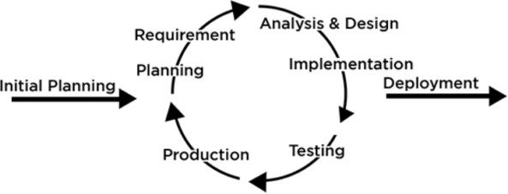

###### **Figure A : Iterative Development Methodology**

**Proposed Architecture:**

This app will adopt a three-tier architecture to ensure scalability, maintainability and security. The three tiers include:

* **Top Layer**: This is where you see and interact with the apps button and screens, like the home screen and settings menu. It is called the ‘Presentation Tier’.
* **Middle Layer**: Here where the app’s main brain does it work, like figuring out your mood from the data you input and guiding you through meditation exercises. It’s known as the ‘Application Tier’.
* **Bottom Layer:** This is like a secure visit where all your personal information such as mood history and user profile is stored. It’s called ‘Data Tier’

.

Each layer has its job the top layer handles what you see, the middle layer handles the app’s functions, and the bottom layer keeps your data safe. This setup helps keep app running smoothly and securely.

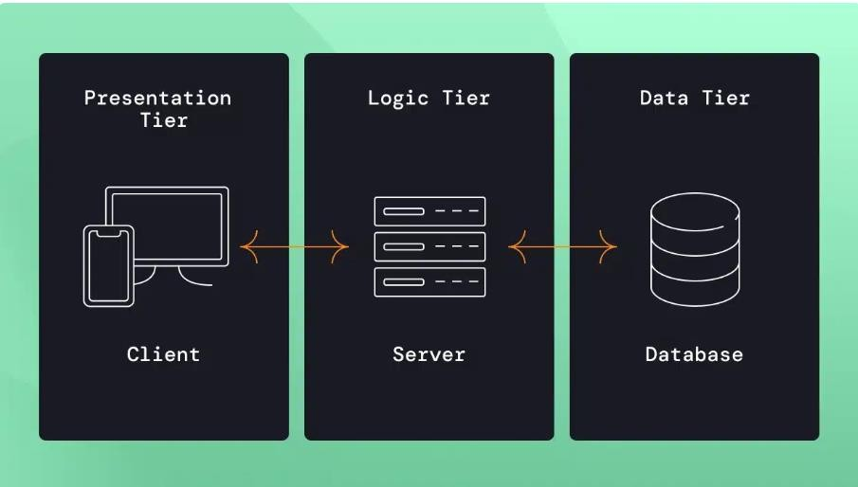

###### **Figure B : Client server 3 tier architecture**

**Requirements:**

**Frontend:**

* **React Native:** React Native will be used for developing the user interface (UI) of the mobile app. React Native offers a single codebase for iOS and Android platforms, enabling faster development and a consistent user experience across devices.
* **JavaScript:** JavaScript will be used as the primary programming language for both frontend and backend development, ensuring a unified development experience across the full stack.

**Backend:**

* **Node.js:** Node.js will be used for building the server-side backend of the app. Node.js allows for efficient handling of I/O operations, particularly for real-time data processing, which is critical in mobile apps
* **Express.js:** A lightweight and flexible web application framework built on Node.js, used for building APIs and handling HTTP requests in the backend.

**Database:**

**MongoDB:** MongoDB will be used as the NoSQL database for storing and handling flexible, JSON-like documents. MongoDB is ideal for handling large amounts of unstructured or semi-structured data and supports high-performance applications with real-time updates.

**Hosting:**

**Render:** Render will be used for deploying and hosting the backend server built with Node.js and Express.js. Render provides cloud-based hosting with simplified deployment, scalability, and automatic SSL certificates, making it ideal for hosting the backend and APIs.

**Other Tools:**

**MongoDB Atlas:** For cloud hosting and managing MongoDB instances, MongoDB Atlas will be used to handle data storage and scalability without needing to manage on-premise infrastructure.

**Contribution:**

This app wants to help people feel better and stronger in their minds. By giving tools to manage stress and bad moods, it hopes to make mental health support easier to get and talk about. With features like tracking how they feel and guides for relaxing, it helps people feel happier. It also lets people connect with others who understand and support them. It gives them information and advice from experts too. With the help of this app, people can set goals and see how they are doing, which helps them handle tough times better. Overall, this app is like a helpful friend, making it easier for everyone to feel good in their mind and live a better life.

**Conclusion:**

This app is just like your friend which helps you feel better. It gives you tools to feel happier and take care of your mental health with features like mood tracking, relaxation guides, and community support, this app makes it easier for everyone to live a better, more balanced life. So, if you want to feel good and stay happy, this app is here to lend a helping hand. So, let’s keep smiling and living our best lives with this app by our side!

# **Chapter 1: Introduction**

## **BACKGROUND:**

The mental health and wellbeing app is created because people are feeling more stressed and anxious these days, and there aren’t enough easy ways to help with these feelings. The app was made to be easy to use and has things like tracking how you feel, listening to calming sessions, and learning ways to deal with stress. It also connects you with others who understand what you are going through. There are many well-known apps which give us such techniques and tools like Wysa, BetterMe, Smiling Mind, VOS, Intellect. Their big goal is to help everyone feel supported and encouraged to take care of their mental health. This app want to help people take care of their minds and make talking about mental less scary.

## **OBJECTIVES:**

* Help people feel less stressed and anxious.
* Provide easy-to-use tools for managing emotions.
* Connect users with supportive communities.
* Make talking about mental health less scary.
* Encourage self-care and well-being.
* Improve the app based on user feedback.
* Make mental health support accessible to everyone.

## **PURPOSE, SCOPE AND APPLICABILITY**

### **Purpose**

The purpose of this app is to help people feel better emotionally and mentally. It provides tools and resources like mood tracking, meditation and stress management techniques to support users in managing their mental health. The app also connect users with supportive communities, making it easier for everyone to prioritize their wellbeing and feel supported.

### **Scope**

The scope of this app is help people with their mental health. It will include features like mood tracking, meditation, and stress relief techniques. Users can also connect with others for support. The app aims to be user-friendly and inclusive for everyone who wants to take care of their mental wellbeing.

### **Applicability**

The applicability of this app is for anyone who wants to take care of their mental health. Whether you’re feeling stressed, anxious or just want to feel better emotionally, this app offers tools and resources to help. It’s for people of all ages and backgrounds who want to prioritize their wellbeing and feel supported in their journey towards better mental health.

**Chapter 2: Survey Of Technologies**

1. **Integrated Development Environment(IDEs):**
2. **Android Studio:**

Platform: Android

Description: Android Studio is the official IDE for Android app development, provided by Google. It offers a comprehensive set of tools for designing, coding, testing, and deploying Android apps. Android Studio is based on IntelliJ IDEA and includes features like code completion, debugging, and performance profiling.

1. **Xcode:**

Platform: iOS, macOS, watchOS, tvOS

Description: Xcode is Apple's IDE for developing apps for iOS, macOS, watchOS, and tvOS. It provides a complete development environment with a code editor, interface builder, testing tools, and performance analysis instruments. Xcode supports multiple programming languages including Swift and Objective-C.

1. **Visual Studio (VS)/Visual Studio Code(VS Code):**

Platform: Cross-platform (Windows, macOS, Linux)

Description: Visual Studio is a powerful IDE developed by Microsoft primarily for Windows-based app development using languages like C#, C++, and Visual Basic. Visual Studio Code (VS Code), on the other hand, is a lightweight, cross-platform code editor that supports a wide range of programming languages and frameworks. Both Visual Studio and VS Code offer extensions for mobile app development, including support for Xamarin for cross-platform mobile development.

1. **IntelliJ IDEA:**

Platform: Cross-platform (Windows, macOS, Linux)

Description: IntelliJ IDEA is a popular Java IDE developed by JetBrains. While it's not specific to mobile app development, it's commonly used for developing Android apps, especially when using Kotlin. IntelliJ IDEA provides advanced code analysis, refactoring tools, and support for various frameworks and technologies.

1. **Eclipse:**

Platform: Cross-platform (Windows, macOS, Linux)

Description: Eclipse is an open-source IDE primarily used for Java development but supports other languages and platforms through plugins. It has been historically popular for Android app development, although its usage has declined with the rise of Android Studio. Eclipse offers features like code refactoring, debugging, and version control integration.

1. **Flutter/DartPad:**

Platform: Cross-platform (Web-based)

Description: DartPad is an online code editor provided by Google for experimenting with the Dart programming language, which is used for building apps with Flutter. While not a full-fledged IDE, DartPad is useful for quick prototyping and learning Dart syntax. Flutter also has extensions for popular editors like Visual Studio Code and IntelliJ IDEA, providing IDE-like features for Flutter development.

**Why I selected VS Code?**

Visual Studio Code (VS Code) is a popular tool for developers because it works on all kinds of computers, it's not too heavy, and it runs really fast. It has lots of extra features that you can add to make it work just the way you want. You can use it to write code in many different languages and frameworks. It helps you write code faster with cool features like IntelliSense, which gives you hints while you're typing. You can also change how it looks and works to suit your style. Lots of people use it, so if you have questions or need help, there are plenty of others who can help you out. Best of all, it's free to use, and anyone can help make it better by sharing their ideas and improvements!

.

1. **Programming Language:**
2. **Java:**

Used for Android app development. Java is the official language for Android development, providing a robust ecosystem of libraries and tools.

1. **JavaScript**:

JavaScript is the most popular language for web and mobile app development. It is used both for frontend (with React Native) and backend (with Node.js), allowing a unified development experience.

1. **Kotlin:**

Kotlin is increasingly becoming the preferred language for Android development due to its modern features, interoperability with Java, and concise syntax. It's fully supported by Google for Android development.

1. **Swift:**

Swift is the primary programming language for iOS, macOS, watchOS, and tvOS app development. It offers safety features, performance improvements, and ease of learning compared to Objective-C.

1. **Objective-C:**

While Swift has largely replaced Objective-C for new iOS development, Objective-C is still used in legacy codebases and some existing iOS apps.

1. **Dart:**

Dart is the language used for Flutter, Google's UI toolkit for building natively compiled applications for mobile, web, and desktop from a single codebase. Flutter allows you to develop cross-platform mobile apps with Dart.

**Why I selected JavaScript?**

JavaScript allows for a full-stack development approach, enabling developers to use the same language on both the frontend and backend. It simplifies the development process by reducing the need for learning multiple languages. Using JavaScript across the stack also improves code consistency and maintains a streamlined workflow.

1. **Database**
2. **SQLite:**

Type: Relational Database Management System (RDBMS)

Description: SQLite is a lightweight, embedded database engine that is widely used for local data storage in mobile apps. It requires minimal setup and configuration, making it easy to integrate into apps. SQLite databases are self-contained and stored as a single file, making them convenient for mobile apps that need to store small to moderate amounts of data.

1. **Realm:**

Type: Mobile Database

Description: Realm is a mobile database designed specifically for mobile app development. It offers real-time synchronization across devices, encryption for data security, and support for offline-first app architectures. Realm provides object- oriented data modeling and integrates seamlessly with popular mobile app frameworks like Flutter, React Native, and Xamarin.

1. **Firebase:**

Type: Cloud-hosted Database

Description: Firebase is a comprehensive platform provided by Google that offers various services for building and running mobile and web apps. Firebase Realtime Database and Cloud Firestore are NoSQL databases offered by Firebase for storing and syncing app data in real time. They are well-suited for applications requiring real- time updates, collaboration features, and offline data synchronization.

1. **MySQL:**

Type: Relational Database Management System (RDBMS)

Description: MySQL is one of the most popular open-source relational databases used for server-side development. It offers high performance, scalability, and reliability, making it suitable for a wide range of applications, from small websites to large-scale enterprise systems. MySQL is commonly used with web frameworks like Django, Ruby on Rails, and Node.js for building backend services.

1. **PostgreSQL:**

Type: Relational Database Management System (RDBMS)

Description: PostgreSQL is an open-source relational database known for its advanced features, extensibility, and SQL compliance. It provides ACID compliance, robust concurrency control, and support for JSON data types and full-text search. PostgreSQL is favored by developers for applications requiring complex data modeling, data integrity, and scalability.

1. **MongoDB:**

Type: NoSQL Database

Description: MongoDB is a popular NoSQL database known for its flexibility, scalability, and ease of use. It stores data in flexible, JSON-like documents, making it suitable for handling unstructured or semi-structured data. MongoDB is commonly used in modern web and mobile app development for its ability to quickly iterate on data models and adapt to changing requirements.

**Why I selected MongoDB?**

MongoDB works seamlessly with JavaScript and Node.js, as it stores data in a JSON-like format, making it easy to work with in the JavaScript ecosystem. Its flexible schema is great for rapidly changing data models, and it can handle real-time, high-performance applications, making it an excellent choice for React Native apps that need fast data updates and synchronization across devices.

1. **Framework**
2. **Flutter:**

Type: UI Toolkit

Description: Developed by Google, Flutter is an open-source UI toolkit for building natively compiled applications for mobile, web, and desktop from a single codebase. It uses the Dart programming language and offers a rich set of pre-built widgets and tools for creating beautiful and performant user interfaces.

1. **React Native:**

Type: UI Toolkit

Description: Developed by Facebook, React Native is an open-source framework for building cross-platform mobile applications using JavaScript and React. It allows developers to write code once and deploy it to multiple platforms, including iOS and Android, while maintaining a native-like user experience.

1. **Xamarin:**

Type: Cross-platform Framework

Description: Developed by Microsoft, Xamarin is an open-source framework for building cross-platform mobile applications using C# and the .NET framework. It allows developers to share code across platforms and access native APIs, libraries, and UI controls, providing a native user experience.

1. **Ionic:**

Type: Hybrid App Framework

Description: Ionic is an open-source framework for building hybrid mobile applications using web technologies such as HTML, CSS, and JavaScript. It provides a set of UI components, themes, and tools for building cross-platform apps that run inside a webview container on native platforms.

1. **AngularJS/Angular**:

Type: Web Application Framework

Description: Developed by Google, AngularJS (Angular 1.x) and Angular (versions 2 and above) are web application frameworks for building single-page applications (SPAs) and progressive web apps (PWAs). They use TypeScript and offer features like two-way data binding, dependency injection, and component-based architecture.

1. **Vue.js:**

Type: Web Application Framework

Description: Vue.js is an open-source JavaScript framework for building user interfaces and single-page applications. It offers a progressive and incrementally adoptable architecture, making it easy to integrate with existing projects. Vue.js emphasizes simplicity, flexibility, and performance.

1. **Electron:**

Type: Desktop Application Framework

Description: Electron is an open-source framework for building cross-platform desktop applications using web technologies like HTML, CSS, and JavaScript. It allows developers to create native-like desktop applications for Windows, macOS, and Linux using a single codebase.

**Why I selected React Native?**

React Native allows you to create high-performance, native-like mobile apps for both iOS and Android from a single codebase. Since you are using JavaScript for both frontend and backend (via Node.js), this reduces the complexity of the app and speeds up development. React Native’s rich set of pre-built components and native API integration ensures that your app performs well across platforms while still providing a smooth and interactive user experience.

# **Chapter 3: Requirement Specification**

## **3.1. Problem Definition**

The system I’ll be developing is like a helpful friend for people’s mental health. It’s an app that offers tools and support to help users feel better emotionally and mentally. Think of it as a place where people can go when they’re feeling stressed, anxious or just need a little pick me up. This app will have features like mood tracking, meditation sessions, and stress relief techniques to help users manage their emotions. It will also connect users with offers who understand what they’re going through, creating a supportive community where people can share their experiences and find encouragement. Overall, this app aims to make taking care of your mental health easier and more accessible for everyone.

* **Sub-System**

Let me give you an insight of the system flow. The system flow of my app involves:

1. **User Registration / Login:**

o Users will begin by registering for an account or logging into the app. This ensures that each user has a personalized experience and secure access to their data. User information is stored securely for future use and interaction with the app.

1. **Mood Tracking:**

o After logging in, users can track their mood using the app’s mood tracking feature. They can select their current mood from predefined options or input their feelings through text or emojis. This feature helps users monitor their emotional state over time, providing insights into their mental health journey.

1. **Tracking data:**

o In addition to mood tracking, users can track other relevant data like sleep patterns, exercise, and daily habits. The app allows users to input or sync data from wearable devices to help provide a holistic view of their well-being. This information can be used to detect patterns that may affect mood or mental health.

1. **Accessing Features:**
   * Users can then access various features of the app tailored to their needs, including:

* Guided Meditation Sessions: These provide users with tools to relax and manage stress.
* Stress Management Techniques: Practical advice and exercises to reduce stress.
* Mental Health Support Resources: Articles, videos, and support networks to help users understand and cope with mental health issues.
* Meal Planning: Users can access a meal planning module where they can create balanced meals or receive recommendations based on their nutritional needs. Meal plans are designed to promote both physical and mental well-being.

1. **Engaging with Community:**

o The app fosters connection by providing a platform for users to engage with a community through forums, chat groups, or peer support networks. This allows users to share their experiences, ask questions, offer support, and connect with others facing similar challenges.

1. **Games Section:**

o To help users manage stress and improve mental well-being, the app includes a Games Section with relaxing games, puzzles, and brain exercises. These games are designed to engage the mind, promote relaxation, and provide users with a fun way to unwind.

1. **Chatbot:**

* Users can initiate a conversation with the app’s chatbot in critical situations when they need immediate assistance or support. The chatbot can provide resources, answer common questions, and guide users through difficult moments, offering help or directing them to further resources.

1. **Feedback and Improvement:**

o The app collects feedback from users through surveys, ratings, or direct input. This helps the development team gather insights about user experiences, identify areas for improvement, and enhance the app’s features and content over time.

1. **Logging out:**

* Once users are done, they can log out of the app. This ensures the security of their account and protects their personal data.

## **3.2. Requirement Specification**

### **3.2.1. Requirement Gathering**

There are various ways of gathering requirements but I opted for google form. Here Is an overview of my google form:

The link for the google form is as follows: [https://docs.google.com/forms/d/e/1FAIpQLScoEDoBMj4gOSY7QMKIHViyJcdK1](https://docs.google.com/forms/d/e/1FAIpQLScoEDoBMj4gOSY7QMKIHViyJcdK1f8g9OpVfuoQfwh9QWy17g/viewform) [f8g9OpVfuoQfwh9QWy17g/viewform](https://docs.google.com/forms/d/e/1FAIpQLScoEDoBMj4gOSY7QMKIHViyJcdK1f8g9OpVfuoQfwh9QWy17g/viewform)

The link for the spreadsheet is a follows: [https://docs.google.com/spreadsheets/d/1g_5DZR-](https://docs.google.com/spreadsheets/d/1g_5DZR-DSCTW9jkqjaUyyqTNaE_Elf72YlpyejNCioM/edit?usp=sharing) [DSCTW9jkqjaUyyqTNaE_Elf72YlpyejNCioM/edit?usp=sharing](https://docs.google.com/spreadsheets/d/1g_5DZR-DSCTW9jkqjaUyyqTNaE_Elf72YlpyejNCioM/edit?usp=sharing)

The following are the results:

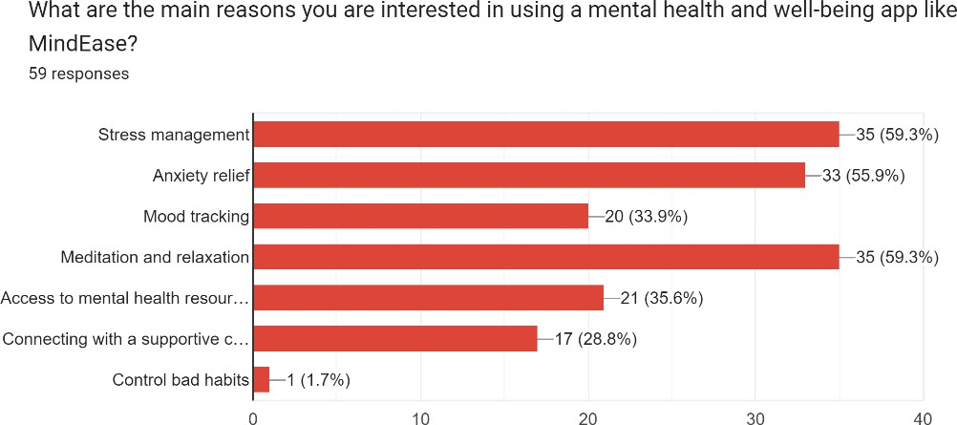

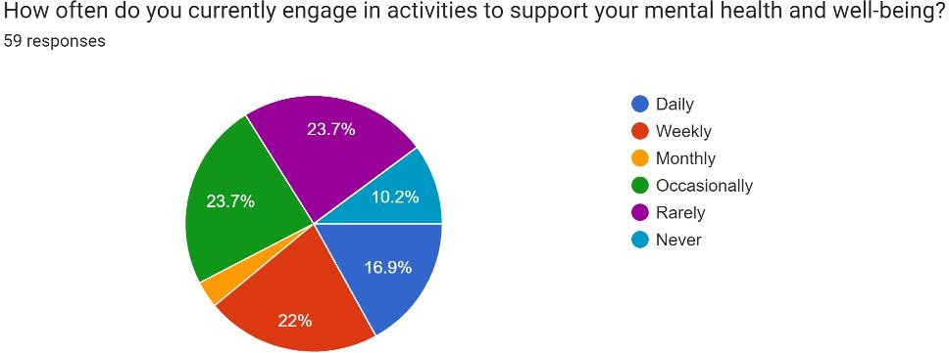

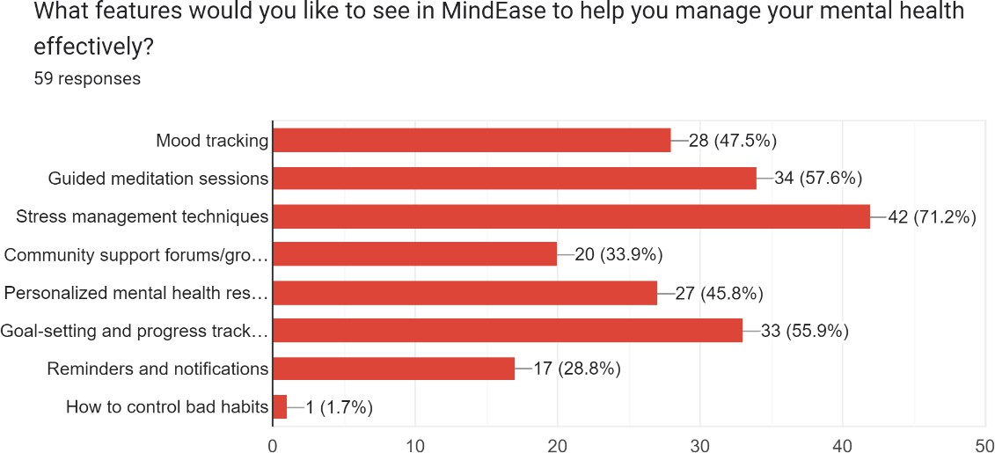

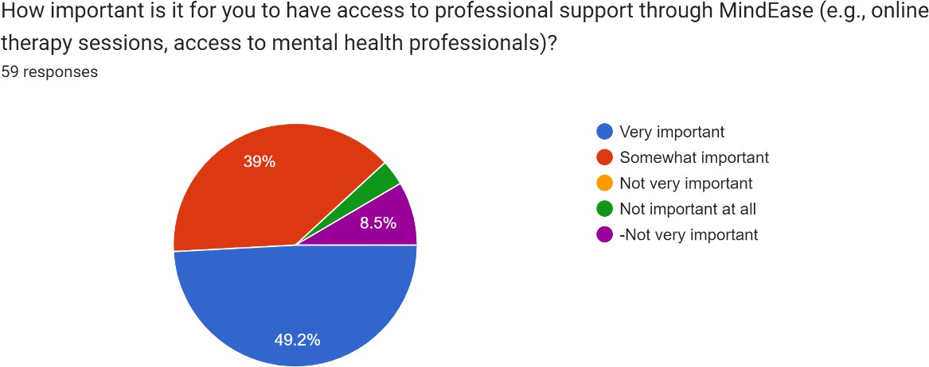

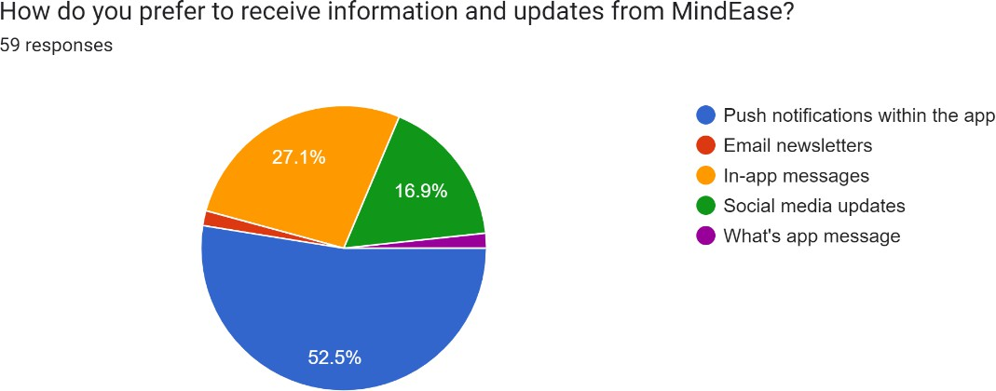

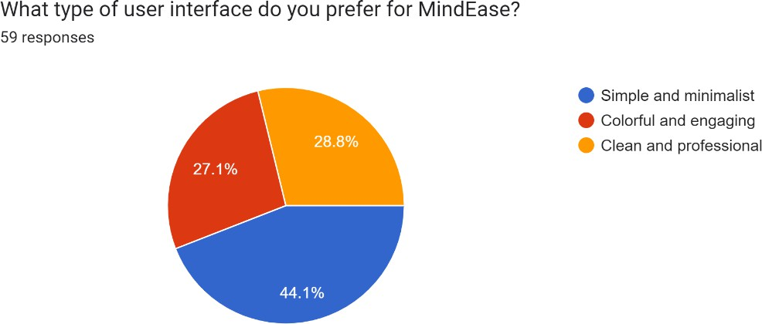



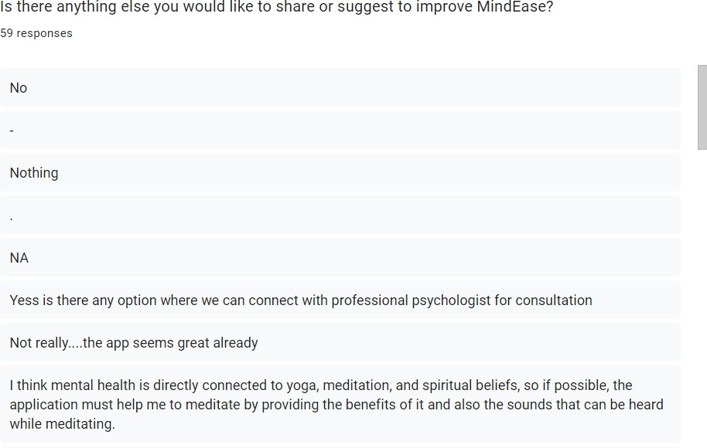

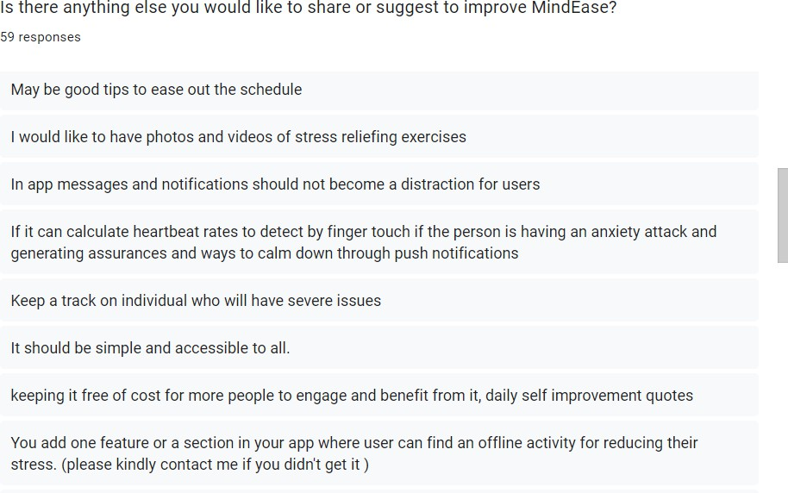

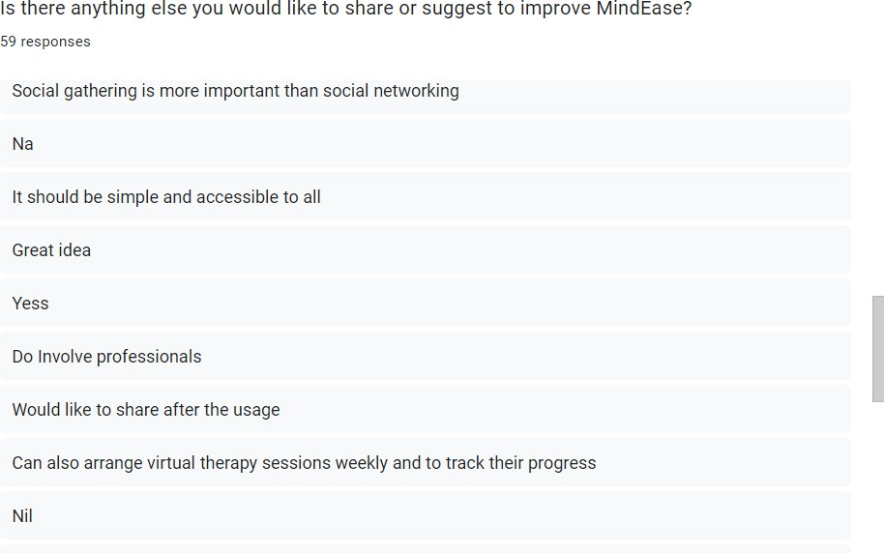

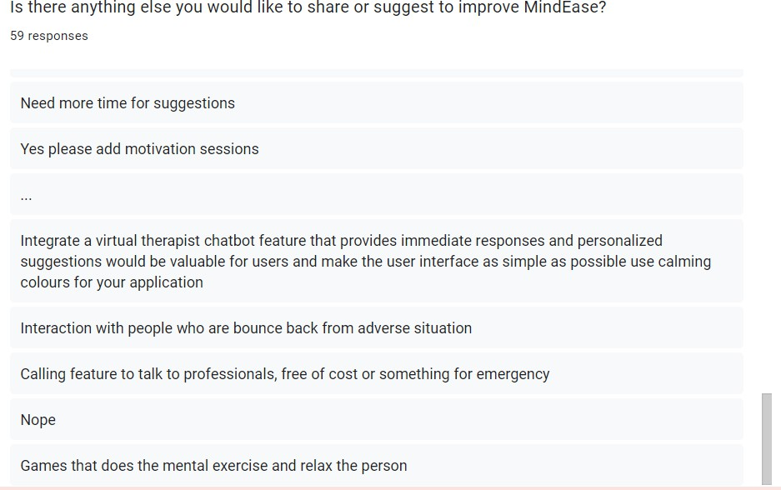

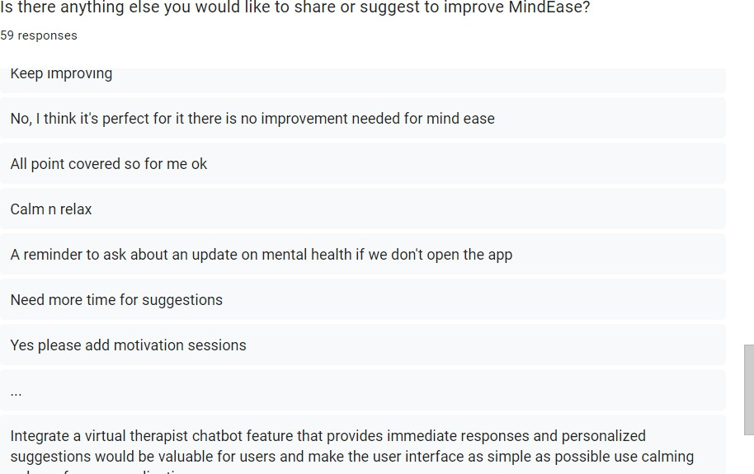

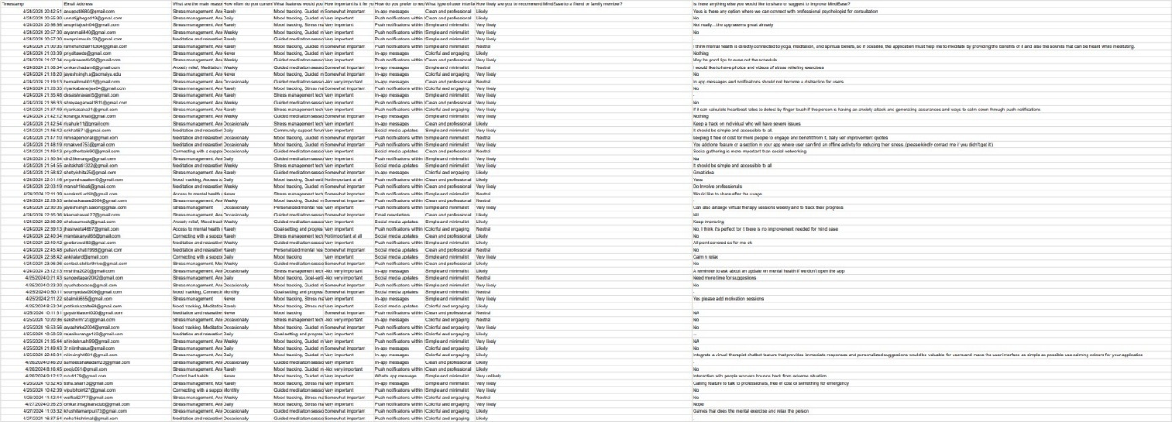

###### **Figure 1.1. Requirement gathered through Google Forms**

### **3.2.2. Requirement Analysis**

The overall analysis of the mental health and wellbeing app requirements includes the following:

1. **Users of the system**

The users of the system include individuals seeking mental health support, such as those with known or unknown mental health issues. Users can create accounts, access personalized content, and communicate with mental health professionals and peer support groups.

1. **User Registration and Authentication**
   1. Users can register securely by providing personal information (name, age, mental health history).
   2. The system provides a simple self-assessment feature to help users identify potential mental health issues and receive personalized content.
   3. Users can log in using email/password or social media platforms, with additional options for password recovery.
2. **Assessment and Tracking**
   1. Users can complete mental health assessments and track their mood, sleep patterns, and stress levels.
   2. Personalized recommendations are provided based on assessment results, offering activities or interventions to improve mental well-being.
3. **Content and Resources**
   1. The system provides access to articles, videos, and guided meditation sessions covering mental health, yoga, meditation, and stress management techniques.
   2. Content is regularly updated based on the latest mental health research.
4. **Communication and Support**
   1. Users can connect with professional psychologists for virtual consultations.
   2. Peer support options include one-on-one messaging, group chats, and community forums for shared experiences and advice.
5. **Goal-Setting and Progress Tracking**
   1. Users can set mental health goals and track their progress over time.
   2. Progress is monitored through milestones and achievements, which are displayed on the user’s dashboard.
6. **Reminders and Notifications**
   1. Users can set reminders for self-care activities, such as meditation or appointments.
   2. The system sends automatic reminders if the user hasn’t logged into the app for a certain period to encourage mental health check-ins.
7. **Suicide Prevention Chatbot**
   1. An AI-powered chatbot is available for users to chat with when they feel low, providing suggestions and guidance on overcoming challenges.
8. **Meal Planning**
   1. Users can access personalized meal plans based on their goals, such as boosting mood or managing stress through nutrition.
   2. The app will suggest healthy recipes that are quick to prepare and include ingredients that support mental clarity and overall well-being.
   3. **c)** Meal planning can be linked to other aspects of the user’s tracking data (e.g., exercise and mood), offering recommendations tailored to both physical and mental health needs.
9. **Games Section:**
   1. Engaging games designed to reduce stress and enhance cognitive functions, such as puzzles, memory games, and mindfulness exercises.
   2. The app will offer a gamification element, where users can unlock achievements, earn rewards, and track their participation in mental well-being games.
   3. The games will promote relaxation and improve users’ mood, providing an interactive and enjoyable way to practice self-care.

#### **3.2.2.1. Functional Requirements:**

* + - * 1. **User Registration and Authentication:**

Users should be able to create accounts securely: The system should provide a user- friendly registration process where users can input their information securely. Upon successful registration, users should receive a confirmation email or message.

User should fill in some basic details like name, age and mental health history so that they can get personalised content.

If user doesn't know what mental disorder he is going through then by giving some simple answer to the question asked by the system they can get an idea of their mental health and accordingly get their content.

Login options should include email/password and social media integration: Users should have multiple options for logging into the system, including traditional email/password authentication and integration with popular social media platforms for convenience.

* + - * 1. **Assessment and Tracking:**

Users can complete mental health assessments and track mood, sleep patterns, and stress levels: The system should provide tools for users to assess their mental health status by answering questions or using self-assessment scales. Users should also be able to track their mood, sleep patterns, and stress levels over time.

The app offers personalized recommendations based on assessment results: Based on the user's assessment results, the system should generate personalized recommendations for activities, resources, or interventions to improve mental well- being.

* + - * 1. **Content and Resources:**

Access to articles, videos, and resources on mental health, yoga, meditation, and stress management techniques: The system should provide a library of educational materials, including articles, videos,journalling and resources covering various aspects of mental health and well-being, such as yoga, meditation, and stress management techniques.

* + - * 1. **Communication and Support:**
* Features for users to connect with professional psychologists or therapists for virtual consultations: The system should facilitate secure between users and mental health professionals for virtual consultations or therapy sessions.
* Option for one-on-one messaging, group chats, or forums for peer support: Users should have options to communicate with peers or support groups through one- on-one messaging, group chats, or forums within the app.
  + - * 1. **Goal-Setting and Progress Tracking:**
* Users can set mental health goals and track their progress over time: The system should allow users to set specific, measurable goals related to their mental health and track their progress towards those goals over time.
* Progress tracking feature allows users to monitor their achievements and milestones: Users should be able to view their progress, milestones, and achievements related to their mental health goals within the app.
  + - * 1. **Reminders and Notifications:**
* Users can set reminders for self-care activities, appointments, or goal deadlines: The system should allow users to set reminders for self-care activities, such as meditation sessions, therapy appointments, or deadlines for achieving mental health goals.
* Automatic reminders for mental health check-ins if the app is not used for a certain period: The system should automatically send reminders to users to check in on their mental health if they haven't used the app for a specified period.
  + - * 1. **Suicide Prevention Chatbot:**

User can chat with the AI Chatbot in case they feel low and the chatbot will suggest and gives ways to the users to overcome that problem.

* + - * 1. **Meal Planning:**
* Personalized meal recommendations based on individual goals (e.g., improving mental clarity, reducing stress).
* Recipes will be provided with nutritional information to guide users in making healthier food choices that promote better mental health.
  + - * 1. **Games Section:**
* A variety of stress-relieving games, cognitive puzzles, and mindfulness exercises will be available to users. These games will be designed to reduce anxiety, improve focus, and offer a positive, fun experience.
* Users will have access to achievements and progress tracking within the games to encourage ongoing participation and improvement.

#### **3.2.2.2 Non-Functional Requirement**

1. **Security**

To keep data safe, use secure connections like HTTPS and encrypt sensitive information so hackers can't access it. For logging in, require more than one form of verification, like a password and a code. Control who has access to sensitive information, and review permissions regularly. Regularly scan your app for security issues and use tools to help fix any potential risks.

1. **Performance**

To improve app speed, write clean code and use tools that help deliver content faster. Manage resources like memory to prevent slowdowns, and load images or data only when needed. Continuously monitor the app’s performance, and test it under heavy loads to fix any slowdowns before they affect users.

1. **Accessibility**

Make sure your app is usable for everyone, including people with disabilities. Follow accessibility guidelines and use tags that support screen readers. Test with these tools to improve usability and gather feedback from users with disabilities. Ensure the app works with different input methods, like keyboards and voice commands, and add text descriptions for images and videos.

1. **Scalability**

Use cloud services to easily add more resources as user numbers grow. Break the app into smaller, scalable parts, and use load balancing to handle traffic. For large amounts of data, split and replicate the database and use caching to access frequent data quickly.

1. **Usability**

Design the app to be simple and easy to use. Test early versions with users to fix problems and improve the design. Use A/B testing to find the best design options. Collect feedback from users and review it regularly to keep improving the app’s usability.

#### **3.2.2.3 System Requirements:**

**1. Function:** **User authentication and management.**

* **Description:** Enables users to create and manage their accounts securely.
* **Inputs**: User credentials (email, password).
* **Source:** User input and email authentication.
* **Output**: User authentication status (success or failure).
* **Action:**
* Users can sign up using their email and password.
* User can log in securely.
* User can recover their password via email
  + **Requires:** Secure storage and retrieval of user credentials.
  + **Precondition**: User provide valid credentials.
  + **Post condition:**
* User session is established on successful authentication.
* Invalid login attempts are handled securely
* **Side effects:** None

1. **Function: Manage user profile.**
   * + **Description:** Allows user to create and update their personal profiles.
     + **Inputs**: User profile information (name, age, mental health, goals).
     + **Source** User input.
     + **Output**: Updated user profile data.
     + **Destination**: User session management system.
     + **Action**:
   * Users can create and update their personal profiles.
   * User can log their mood daily and view their mood history.

* **Requires:**
  + A database for storing user profile information.
  + User interface for profile management.
    - **Precondition**: User is authenticated.
    - **Post condition**: User profile data is updated in the database.
* **Side effects**: None

1. **Function: Mental health assessment.**
   * + **Description**: Provides mental health assessment and personalized recommendation in user responses to assessment questions.
     + **Source**: User input.
     + **Output**: Assessment results and personalized recommendations.
     + **Destination**: Users personalized dashboard.
     + **Actions:**
   * User can take various mental health assessment.
   * The system provides personalized recommendations based on assessment results.
     + **Requires**: A database of assessment questions and algorithms for generating recommendation.
     + **Precondition:** User is authenticated.
     + **Post condition**: Assessment results and recommendations are displayed with the user.

* **Side effects**: None.

1. **Function: Communication and support.**
   * + **Description:** Enables user to connect with professional psychologist and participation in the community support forums.
     + **Inputs**: User request for consultation or forum participation. **Source**: User Input and professional consultation booking system. **Output**: Scheduled consultations and forum interactions.
     + **Destination**: User’s personalized dashboard and community support system.
     + **Actions:**
   * Users can book virtual consultations with professional psychologist.
   * User can participate in community support forums.

* **Requires:**
  + The integration with professional consultation booking systems.
  + A forum system for community support.
    - **Precondition:** User is authenticated**.**
    - **Post condition**: Consultations are scheduled and forum interactions are locked.
* **Side effects**: None.

1. **Function: Content and resource available**.

* **Description:** Providing access to mental health resources, including articles, videos and guided meditations.
* **Inputs**: Users request for content.
* **Source**: Content management system.0
* **Output**: Requested articles videos and meditation sessions.
* **Destination**: User’s personalized dashboard.
* **Actions:**
* Users can access articles videos and guided meditation sessions.
* The system updates content regularly based on the latest mental health research.
* **Requires:**
* A content management system.
* Regular updates to content based on medical health research.
* **Precondition:** User is authenticated.
* **Post condition**: Requested content is displayed to the user.
* **Side effects**: None

1. **Function: Reminder and notification.**
   * + **Description:** Send reminders and notifications for activities and health check-ins.
     + **Inputs**: User defined reminder settings.
     + **Source**: User input and system generated reminders
     + **Output**: Reminders and notifications.
     + **Destination**: User’s device (through push notifications).

* **Actions:**
* Users can set reminders for activities like meditation, exercise and appointments.
* The system sends health check-ins reminders if the user hasn’t logged in for a specified.
  + - **Requires**: A notification system integrated with user devices.
    - **Precondition:** User is authenticated.
    - **Post condition**: Reminders and notifications are sent to the users.
    - **Side effects**: None

1. **Function**: **Goal setting and progress tracking.**
   * + **Description:** Allows user to set mental health goals and track their progress over time.
     + **Inputs**: User defined goals and progress updates
     + **Source**: User input.
     + **Output**: Goal status and progress report.
     + **Destination**: User’s personalized dashboard
     + **Actions:**
   * Users can set mental health goals.
   * The system tracks and displays progress towards these goals.

* **Requires**: A database for storing goals and progress data.
* **Precondition:** User is authenticated.
  + - **Post condition**: Goals and progress data are updated in the database.
    - **Side effects**: None

1. **Function: Stress management techniques**.
   * + **Description:** Provides the user with techniques and exercise to manage stress.
     + **Inputs**: User requests for stress management resources.
     + **Source**: Content management system.
     + **Output**: Stress management techniques and exercise instructions.
     + **Destination**: User’s personalized dashboard.
     + **Actions:**

* Users can access various stress management techniques and exercises.
* The system offers instructional videos and return guides
* **Requires**: A content management system with stress management resources.
* **Precondition:** User is authenticated.
* **Post condition**: Requested stress management resources are displayed to the user.
* **Side effects**: None

1. **Function: Community support forum or groups**.
   * + **Description:** Facilitates user interaction and support to community forum or groups.
     + **Inputs**: Users post and interactions.
     + **Source**: User input.
     + **Output**: Forum discussions and group interactions.
     + **Destination**: Community Support Forum.
     + **Actions:**

* Users can post in forums or joint support groups.
* User can interact with other members and offer or receive support.
* **Requires**: A forum system for managing user’s posts and interaction. **Precondition:** User is authenticated.
  + - **Post condition**: Forum post and group interaction are logged.
    - **Side effects**: None

1. **Function**: **Mood tracking.**
   * + **Description:** Tracks user mood overtime and provides insight.
     + **Inputs**: User reported mood levels.
     + **Source**: User input.
     + **Output**: Mood history and insights.
     + **Destination**: User’s personalized dashboard
     + **Actions:**
   * Users can lock their mood daily.
   * The system analysis and displays mood trends and insights.
     + **Requires**: A database for storing mood logs and an analysis tool for generating insights.
     + **Precondition:** Mood data is updated in the database, and insights are displayed.
     + **Post condition**: User is authenticated.
     + **Side effects**: None
2. **Function: Guided meditation sessions.**
   * + **Description:** Provides guided meditation sessions to users.
     + **Inputs**: User selection of meditation sessions.
     + **Source**: Content management system. **Output**: Guided meditation audio or video. **Destination**: Users device.

* **Actions:**
  + Users can select and participate in guided meditation sessions.
  + The system streams or downloads meditation content.
* **Requires:**
  + A Library of guided meditation sessions.
  + Streaming or downloading capabilities
    - **Precondition:** User is authenticated.
    - **Post condition**: Meditation session is delivered to the user.
    - **Side effects**: None

1. **Function: Meal Planning and Recommendations**

* **Description**: Provides users with personalized meal plans based on their mental and physical health needs.
* **Inputs**: User dietary preferences, health goals, and restrictions (e.g., vegetarian, low-carb, etc.).
* **Source**: User input, app's algorithm for generating meal plans.
* **Output**: Daily/weekly meal plans, personalized recipes, nutritional information.
* **Action**:
  + Users can input their dietary preferences and health goals (e.g., stress reduction, improved focus).
  + The system generates meal plans and recipes tailored to the user’s needs.
  + Users are notified of meal prep suggestions and ingredients.
* **Requires**: A comprehensive database of recipes and nutritional information, secure storage of user preferences and health goals.
* **Precondition**: User has filled out their dietary preferences and health goals.
* **Postcondition**:
  + Users receive personalized meal plans with detailed instructions.
  + Meal prep suggestions and notifications are delivered to the user.
* **Side effects**: None

1. **Function: Games and Cognitive Exercises**

* **Description**: Provides users with engaging games and cognitive exercises to help improve mental well-being, reduce stress, and enhance focus.
* **Inputs**: User participation in games, scores, completion data.
* **Source**: User input, app’s game engine.
* **Output**: Game results, achievements, and progress tracking.
* **Action**:
  + Users can select games designed for mental wellness (e.g., memory exercises, stress-relief games).
  + The system tracks user progress and achievements.
  + Users can set goals within games (e.g., improving stress reduction, cognitive function).
* **Requires**: A library of mental wellness games, a system to track user progress and achievements.
* **Precondition**: User must be logged in and actively participating in the games section.
* **Postcondition**:
  + User progress is tracked, and achievements are displayed on their profile.
  + Users receive notifications to encourage continued participation in games.
* **Side effects**: None

## **3.3. Planning and Scheduling**

|  |  |  |  |  |  |
| --- | --- | --- | --- | --- | --- |
| **Task No.** | **Task Name** | **Start Date** | **End Date** | **Actual Start Date** | **Actual End date** |
| T1 | Chapter 1 | 14-11-2024 | 15-11-2024 | 15-11-2024 | 16-11-2024 |
| T2 | Chapter 2 | 16-11-2024 | 17-11-2024 | 17-11-2024 | 18-11-2024 |
| T3 | Chapter 3 | 18-11-2024 | 19-11-2024 | 19-11-2024 | 21-11-2024 |
| T4 | Chapter 4 | 20-11-2024 | 23-11-2024 | 22-11-2024 | 25-11-2024 |
| T6 | Module 1 : User Authentication | 22-11-2024 | 15-12-2024 | 01-12-2024 | 25-12-2024 |
| T7 | Module 2 : Mood Tracking | 16-12-2024 | 25-12-2024 | 26-12-2024 | 02-01-2025 |
| T8 | Module 3 : Meal Planning | 25-12-2024 | 30-12-2024 | 03-01-2025 | 08-01-2025 |
| T9 | Module 4 :User management | 02-01-2025 | 10-01-2025 | 05-01-2025 | 15-01-2025 |
| T10 | Module 5 : Journal Module | 11-01-2025 | 20-01-2025 | 07-01-2025 | 23-02-2025 |
| T11 | Module 6 : Habit Tracker | 21-01-2025 | 26-01-2025 | 21-01-2025 | 26-02-2025 |
| T12 | Module 7 : Activity tracking | 27-01-2025 | 31-01-2024 | 05-01-2025 | 10-01-2025 |
| T13 | Module 8 : Games Section | 01-02-2025 | 15-02-2024 | 10-01-2025 | 27-02-2025 |
| T14 | Module 10 : Mood History Page | 16-01-2025 | 19-01-2025 | 17-01-2025 | 25-01-2025 |
| T15 | Module 11 : Stats Page | 21-01-2025 | 24-01-2025 | 22-01-2025 | 30-01-2025 |
| T16 | Module 12 : Activity History Page | 26-01-2025 | 29-01-2025 | 27-01-2025 | 01-02-2025 |
| T17 | Module 13 : Reminder System | 15-02-2025 | 23-02-2025 | 15-02-2025 | 27-02-2025 |
| T18 | Final Testing | 24-02-2025 | 28-02-2025 | 24-02-2025 | 27-02-2025 |

***Table 3.1 : Planning and Scheduling***

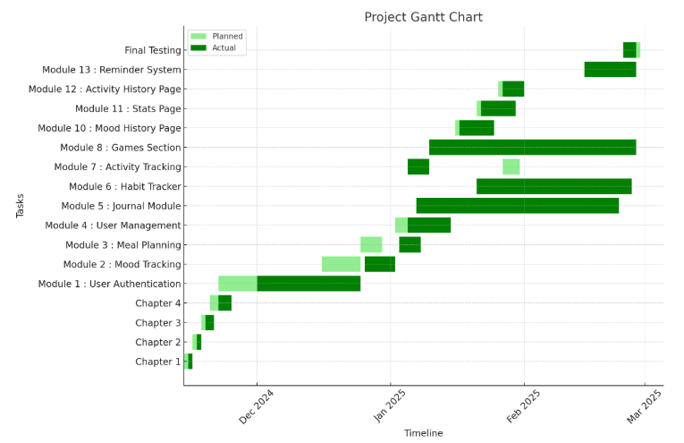

###### **Figure 3.1 : Gantt Chart**

## **3.4. Software and Hardware Requirement (Need)**

**Frontend:**

* **React Native:** React Native will be used for developing the user interface (UI) of the mobile app. React Native offers a single codebase for iOS and Android platforms, enabling faster development and a consistent user experience across devices.
* **JavaScript:** JavaScript will be used as the primary programming language for both frontend and backend development, ensuring a unified development experience across the full stack.

**Backend:**

* **Node.js:** Node.js will be used for building the server-side backend of the app. Node.js allows for efficient handling of I/O operations, particularly for real-time data processing, which is critical in mobile apps
* **Express.js:** A lightweight and flexible web application framework built on Node.js, used for building APIs and handling HTTP requests in the backend.

**Database:**

* **MongoDB:** MongoDB will be used as the NoSQL database for storing and handling flexible, JSON-like documents. MongoDB is ideal for handling large amounts of unstructured or semi-structured data and supports high-performance applications with real-time updates.

**Hosting:**

* **Render:** Render will be used for deploying and hosting the backend server built with Node.js and Express.js. Render provides cloud-based hosting with simplified deployment, scalability, and automatic SSL certificates, making it ideal for hosting the backend and APIs.

**Other Tools:**

* **MongoDB Atlas:** For cloud hosting and managing MongoDB instances, MongoDB Atlas will be used to handle data storage and scalability without needing to manage on-premise infrastructure.

# **Chapter 4: System Design**

## **4.1. Business Rule**

1. **Privacy and Data Security**
   * User data must be securely stored and protected.
   * Compliance with GDPR, HIPAA, and other privacy laws.
   * Access to sensitive data is restricted to authorized personnel.
2. **Informed Consent**
   * Users must provide clear consent before using the app.
   * They should understand data usage and agree to the terms of service.
   * Explicit consent is required for data collection and sharing.
3. **User Safety**
   * The app provides immediate access to emergency contacts.
   * Users in crisis are directed to mental health professionals or hotlines.
   * The app is not a substitute for professional mental health treatment.
4. **Personalized Wellness Plans**
   * Wellness recommendations are based on user preferences and needs.
   * Plans adapt through regular check-ins and self-assessments.
5. **Evidence-Based Content**
   * Content, self-help tools, and exercises follow scientific research.
   * Best practices in mental health are applied.
6. **User Feedback and Progress Tracking**
   * Users can track mental health progress.
   * Feedback options ensure continuous app improvement.
7. **Access to Mental Health Professionals**
   * Users can chat or video call licensed professionals.
   * The app ensures professionals meet necessary qualifications.
8. **Inclusivity and Accessibility**
   * Designed for all users, including those with disabilities.
   * Features like voice commands, text-to-speech, and high contrast modes are included.
9. **Clear Pricing and Subscription**
   * Transparent pricing, subscription tiers, and cancellation policies.
   * Users are informed about free trials and in-app purchases.
10. **Progress Monitoring and Reporting**

* Users can generate reports on mental health progress.
* Reports can be shared with professionals if needed.

## **4.2. Module Diagram**

A module diagram represents the structure of a system by displaying its modules (components) and how they interact. It shows the dependencies between modules, helping to understand how the system is divided and how components work together. Module diagrams are useful for system architecture and software design.

* + 1. **User management:**

**1.1 Registration/Login**: Sign up and Login users.

**1.2 Profile management**: Update personal information and preferences.

**1.3 Password management**: Change and recover password.

* + 1. **Psychologist Management:**

**2.1 Registration/Login:** Sign up and Login Psychologist.

**2.2 Profile management:** Update professional details and availability.

* + 1. **Mood Tracking:**

**3.1 Log mood:** Record mood entries.

**3.2 View mood history:** See past mood entries.

* + 1. **Journal Management:**

**4.1 Create Journal Entry:** Write and save journal entries.

**4.2 View Journal History:** See past journal entries.

* + 1. **Activity Tracking:**

**5.1 Log Activity:** Record activities.

**5.2 View activity History**: See past activities.

* + 1. **Appointment Management:**

**6.1 Book appointment:** Schedule appointments with Psychologists.

**6.2 View Appointments:** See upcoming and past appointment.

**6.3 Send Reminders:** Notify users about appointment.

* + 1. **Resource Management:**

**7.1 Browse resources:** Access articles, videos and other resources.

**7.2 Search resources:** Find resources based on keywords.

* + 1. **Meal Planning:**

**8.1 Create Meal Plan**: Users can create personalized meal plans by selecting dietary preferences, meal types, and schedules.

**8.2 Update Meal Plan:** Users can modify existing meal plans to reflect changes in their dietary needs.

**8.3 View Meal Plan**: Users can view their saved meal plans, including daily and weekly meal schedules.

**8.4 Delete Meal Plan**: Users can remove meal plans they no longer need.

* + 1. **Games Section:**

**10.1 Select Game:** Users can browse and choose therapeutic or relaxation games for mental engagement.

**10.2 Play Game:** Users can interact with selected games to improve mental health through gamified experiences.

**10.3 View Game Progress:** Users can track their achievements, scores, and milestones reached in the games

**Module diagram:**

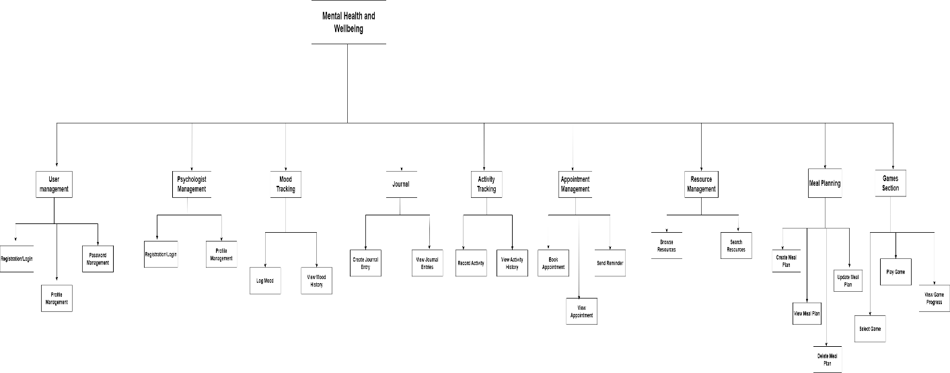

###### **Figure 4.1: Module Diagram**

## **4.3. Data Model**

The Mera Mann app follows a hybrid schema model in MongoDB, combining document-based storage, embedded documents, and references to ensure optimized performance, scalability, and efficient data retrieval.

**Flexibility of MongoDB Schema:**

* Documents within a collection do not have to follow a fixed structure, allowing flexibility in data storage.
* Different documents can store varying data types while maintaining consistency through schema validation.
* A mix of embedded data and references ensures an efficient balance between data normalization and query performance.

**Approaches for Linking Related Data:**

**1. Document-Based Storage**

* This approach is used when each entity operates independently and does not require frequent data lookups from other collections.
* **Used in:**
  + **User Details Model** → Each user is stored separately for authentication and profile management.
  + **Habit Tracking Model** → Habits are stored independently, linked to users through userEmail.
  + **Mood Tracking Model** → Moods are stored as separate records, allowing efficient retrieval using indexed userEmail.

**2. Embedded Documents**

* Embedded documents allow structured data to be stored within a single document, reducing the need for multiple queries.
* **Used in:**
  + **Meal Planning Model** → Stores multiple meal items in an array within a document for fast retrieval.
  + **Daily Tracking Model** → Stores to-do lists, morning routines, water intake, and productivity data in a single document.

**Advantages of Embedded Data:**

* Improves read performance by fetching all relevant data in a single query.
* Reduces the need for complex joins and multiple database lookups.

**3. References (For Normalization and Efficient Querying)**

* References create links between collections using unique identifiers, reducing data redundancy.
* **Used in:**
  + **Journal Entry Model** : References userId from the User Details collection, ensuring user-journal relationships are maintained.
  + **Daily Tracking Model** :References userId to associate daily tracking records with users.

**Advantages of Using References:**

* Ensures data consistency by maintaining separate collections for users and related entities.
* Optimizes database operations by reducing data duplication and ensuring efficient indexing.
* Supports scalability by enabling separate growth of related collections.

**Reason for Selecting a Hybrid Approach in Mera Mann App:**

By combining document-based storage, embedded documents, and references, the Mera Mann app achieves:

* **Optimized Query Performance** : Embedded data speeds up retrieval for structured data like meal plans and daily tracking.
* **Data Normalization & Integrity** : References prevent redundancy, ensuring data consistency across collections.
* **Scalability & Flexibility** : Independent document storage for users, moods, and habits allows the system to grow efficiently.

This hybrid MongoDB schema ensures efficient data management, scalable performance, and optimized querying for a seamless user experience in the Mera Mann mental health and wellbeing app.

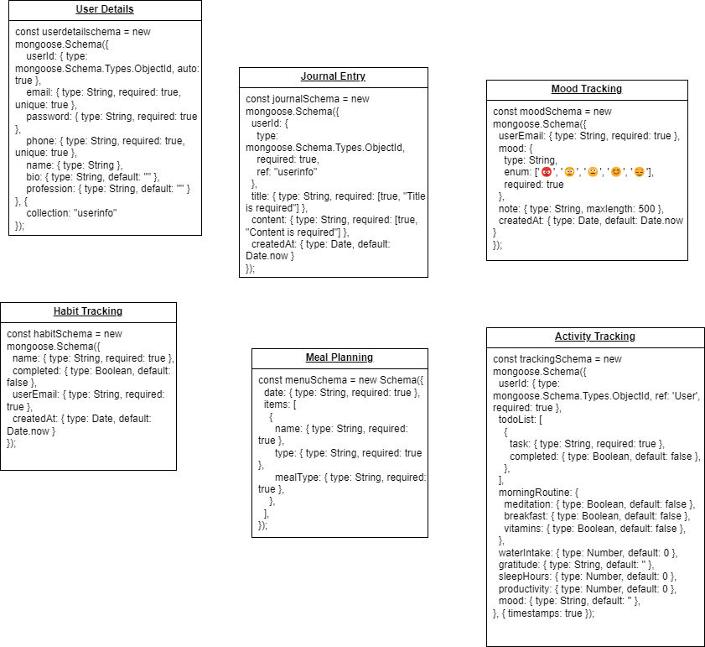

###### **Figure 4.2 : Data Model Diagram**

## **4.4. Data Flow Diagram**

A Data Flow Diagram (DFD) visually represents how data moves through a system. It shows the flow of data between processes, data stores, and external entities. DFDs help in understanding system functionality by breaking it down into simple, logical steps, and highlighting how informational is processed and stored.

|  |  |  |
| --- | --- | --- |
| Name | Symbol | Description |
| Process |  | A process transforms incoming data flow into outgoing data flow. |
| Database |  | Data stores are repositories of data in the system. |
| Data Flow |  | Data flows are pipelines through which packets of information flow. Label the arrows with the name of the data that moves through it. |
| External Entity |  | External entities are objects outside the system, with which the system communicates. |

***Table 4.1. Data Flow Diagram Symbols***

### **4.4.1. Context Level DFD**

Represents the entire system as a single process, shows external entities interacting with the system. (Example, user psychologist). High-level data exchanges between external entities and the system.

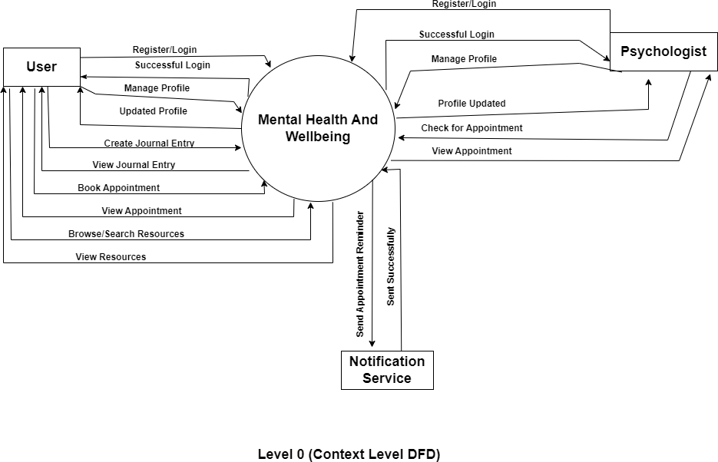

###### **Figure 4.3 Context Level DFD**

### **4.4.2. Level 1 DFD**

Breaks down the single process from the Level 0 into sub-processes. Shows key functional areas of the system (Example, User Registration, mood Logging). Explains internal data exchanges between subprocesses and external activities.

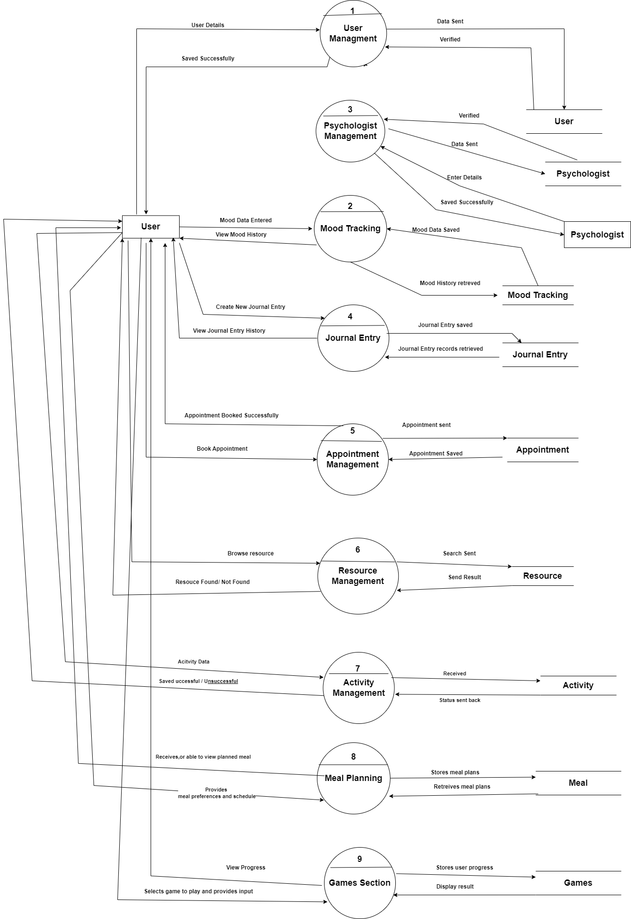

###### **Figure 4.4. Level 1 DFD**

### **4.4.3. Level 2 DFD**

Further details individual sub-processes from Level 1. Shows more granular functionality (Example., validating login, processing mood data). Defines specific data inputs and outputs of each sub-process.

**4.4.3.1. User Management**: Handles user registration, login, profile updates and password management

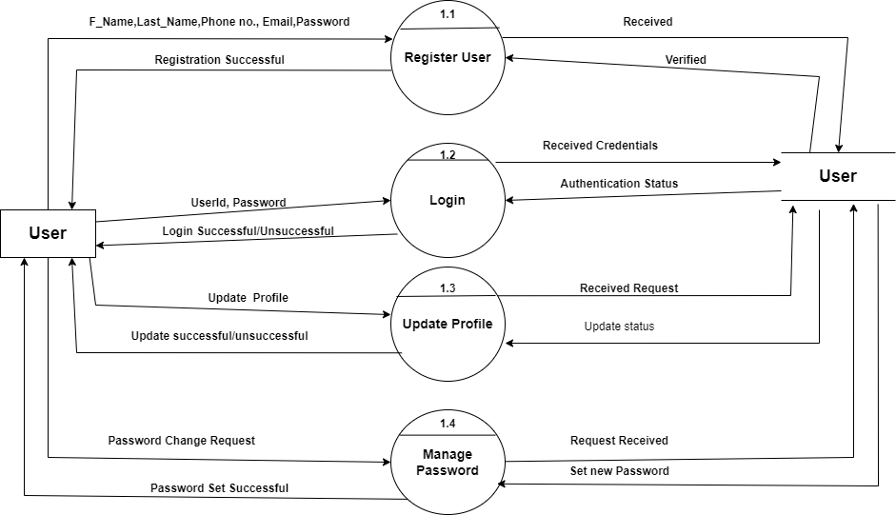

###### **Figure 4.5. Level 2 DFD (User Management)**

**4.4.3.2. Mood Tracking**: Allows users to log mood entries and view their mood history.

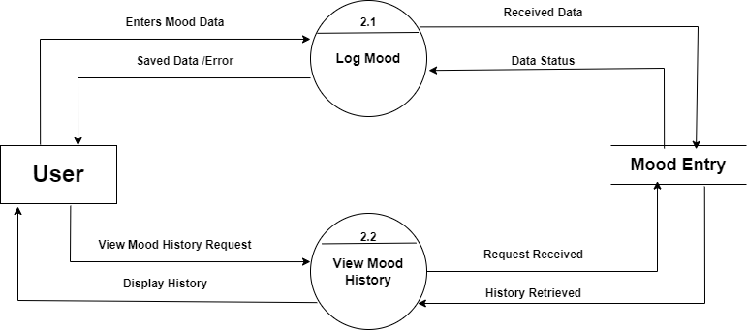

###### **Figure 4.6. Level 2 DFD (Mood Tracking)**

**4.4.3.3. Journal Entry**: Enables users to create and view journal entries.



###### **Figure 4.7 Level 2 DFD (Journal Entry Management)**

**4.3.3.5. Appointment Management**: Manages appointment booking, viewing and sending reminders

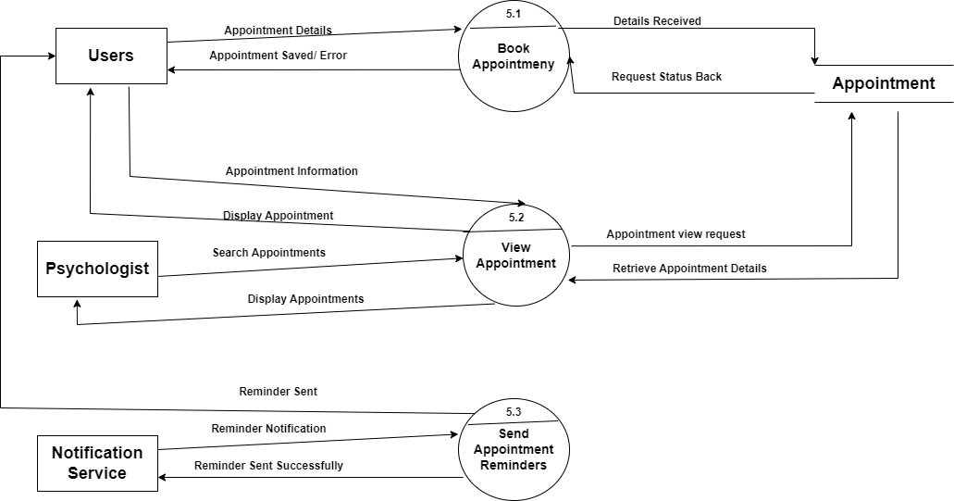

###### **Figure 4.8 Level 2 DFD (Appointment Management)**

**4.4.3.6. Resource Management:** Provides access to various resources and allows searching and filtering.

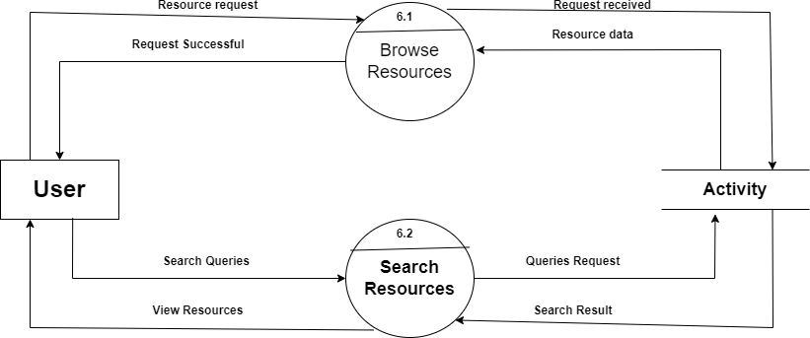

###### **Figure 4.9 Level 2 DFD (Resource Management)**

**4.4.3.7. Activity Tracking**: Allows users to log activities and view their activity history.

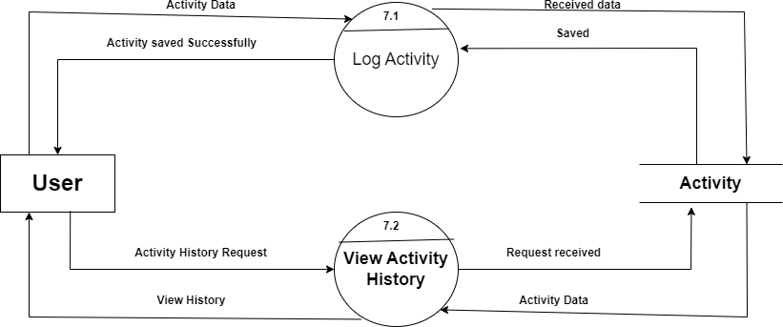

###### **Figure 4.10 Level 2 DFD (Activity Tracking)**

**4.4.3.8. Meal Planning**: Allows users to add meal plan and view the planned meal along with schedule

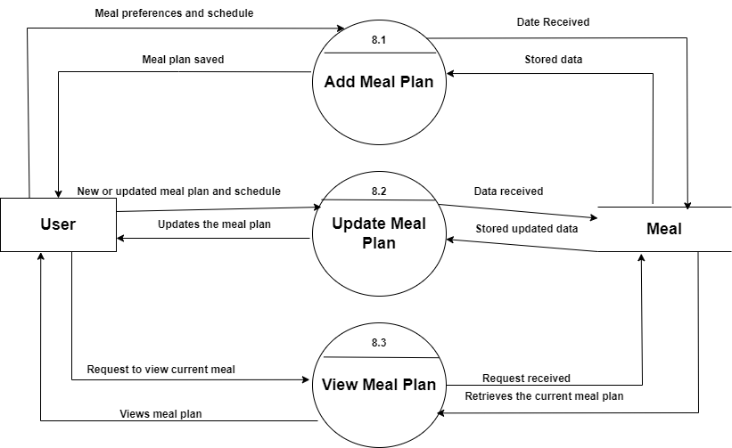

###### **Figure 4.11. Level 2 DFD (Meal Planning)**

## **4.5. Use Case Diagram**

A use case diagram at its simplest is a representation of a user's interaction with the system that shows the relationship between the user and the different use cases in which the user is involved. A use case diagram can identify the different types of users of a system and the different use cases and will often be accompanied by other types of diagrams as well. The use cases are represented by either circles or ellipses. Symbols Reference: <https://www.lucidchart.com/>

|  |  |  |
| --- | --- | --- |
| Name | Symbol | Description |
| Actor |  | Actor represents a user or another system that will interact with the system you are modelling |
| Use case |  | A use case is an external view of the system that represents some action the user might perform in order to complete a task. |
| Associations |  | Association between use cases. |
| Include Relationship |  | Include relationship between the use cases |

***Table 4.2. Use Case Symbols***

### **4.5.1. Use Case Diagram**

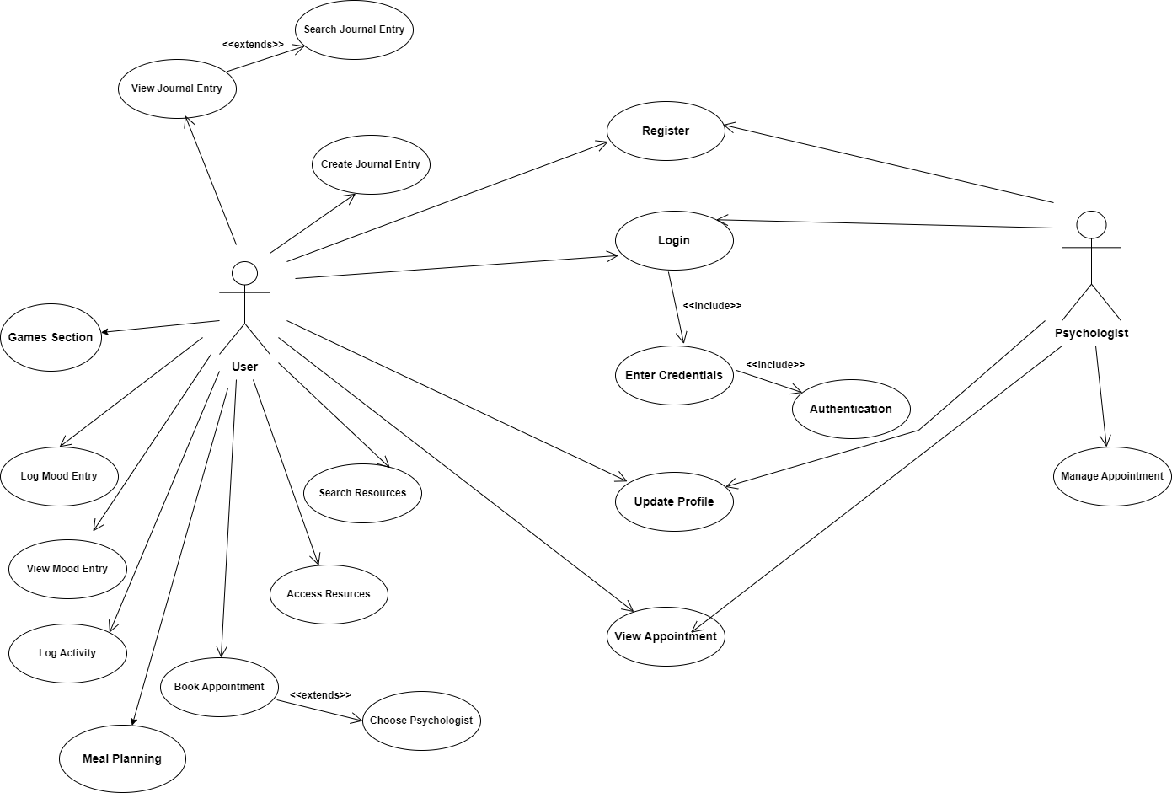

###### **Figure 4.12. Use Case Diagram**

### **4.5.1. Use case Description**

**1. Register**

* **Use case**: Register
* **Summary**: Create a new account
* **Actors**: Psychologist, user
* **Preconditions**: Have the app and internet access
* **Description**: Fill in the registration form and confirm your email
* **Exceptions**: Email already used, wrong information
* **Post condition**: Account is created and a confirmation email is sent.

1. **Login**

* **Use case:** Login
* **Summary:** Log into the app
* **Actors:** User, Psychologist
* **Preconditions:** Must have an account
* **Description:** Enter your email and password to Login
* **Exceptions:** Wrong email or password
* **Post condition:** Logged into the app , last login date is updated.

1. **Updated Profile**

* **Use case:** Update Profile
* **Summary:** Change your profile information
* **Actors:** User, Psychologist
* **Preconditions:** Must be logged in
* **Description:** Edit your profile information and save changes
* **Exceptions:** Wrong information.
* **Post condition:** Profile info updated

1. **Log Mood Entry**

* **Use Case:** Log Mood Entry
* **Summary:** Record how you feel and also notes if any
* **Actors:** User
* **Preconditions:** Must be logged in
* **Description:** choose a mood rating, add notes and save
* **Exceptions:** Can't save mood entry
* **Post condition:** Mood entry is saved

1. **View Mood History**

* **Use case:** View mood history
* **Summary:** Look at the past mood entries.
* **Actors:** user
* **Preconditions:** Must be logged in, must have mood entries
* **Description:** Go to the mood history and see past entries
* **Exceptions:** Can't retrieve mood entries.
* **Post condition:** Past mood entries are displayed.

1. **Create Journal Entry**

* **Use case:** Create Journal entry
* **Summary:** Write a new journal entry
* **Actors:** User
* **Preconditions:** Must be logged in.
* **Description:** Write your journal entry, add tags and save.
* **Exceptions:** Can't save journal entry
* **Post condition:** Journal entry is saved.

1. **View Journal Entry**

* **Use case:** View journal history
* **Summary:** Look at the past journal entries
* **Actors:** User
* **Preconditions:** Must be logged in, must have journal entries.
* **Description:** Go to journal history and see past entries.
* **Exceptions:** Can't retrieve journal entries.
* **Post condition:** Past journal entries are displayed.

1. **Log Activity**

* **Use case:** Log Activity
* **Summary:** Record details of an Activity
* **Actors:** User
* **Preconditions:** Must be logged in.
* **Description:** Enter activity details and save.
* **Exceptions:** Can't save Activity log.
* **Post condition:** Activity log is saved.

1. **View Activity History**

* **Use case:** View Activity history
* **Summary:** Look at the past activities
* **Actors:** User
* **Preconditions:** Must be logged in, must have Activity logs.
* **Description:** Go to Activity history and see past logs.
* **Exceptions:** Can't retrieve Activity log.
* **Post condition:** Past activity logs are displayed.

1. **Book Appointment**

* **Use case:** Book Appointment
* **Summary:** Schedule an appointment with a psychologist.
* **Actors:** User
* **Preconditions:** Must be logged in, must have available psychologists and time slots.
* **Description:** Choose a psychologist and time slot, then confirm.
* **Exceptions:** Time slot not available, can't save appointment.
* **Post condition:** Appointment is saved, psychologist is notified

1. **View Appointment**

* **Use case:** View Appointments
* **Summary:** Look at upcoming and past appointments.
* **Actors:** User, Psychologist.
* **Preconditions:** Must be logged in, must have appointment.
* **Description:** Go to the appointments and see details.
* **Exceptions:** Can't retrieve appointments.
* **Post condition:** Appointments are displayed

1. **Access Resources**

* **Use Case:** Access Resources
* **Summary:** Browse mental health Resources.
* **Actors:** User
* **Preconditions:** Must be logged in, must have resources.
* **Description:** Go to resources and see the list.
* **Exceptions:** Can't retrieve resources.
* **Post condition:** Resources are displayed

1. **Meal Planning**

• **Use case:** Create Meal Plan

• **Summary:** Allows the user to create a personalized meal plan.

• **Actors:** User

• **Preconditions:** User must be logged into the app and have internet access.

• **Description**: The user selects food preferences, dietary restrictions, and meal schedules, then saves the plan.

• **Exceptions**: Invalid data input, server error.

• **Post-condition:** Meal plan is created and saved in the user’s profile.

1. **Games Section**

* **Use case**: Play Game
* **Summary**: Allows the user to play mental health-related games.
* **Actors**: User
* **Preconditions**: The user must be logged in and have an internet connection.
* **Description**: The user selects a game, interacts with it, and completes the session.
* **Exceptions**: Game loading issues, app crash.
* **Post-condition**: Game progress is saved.

## **4.6. Scenario**

* 1. **User Registration**
* User opens the app.
* System displays the registration screen.
* User enter personal details (first name, last name, email, password, date of birth, gender, phone no., address)
* System validates the entered details.
* If any required fields are missing, system displays an error message and prompts the user to fill in the missing details.
* If the email is already registered, system displays an error message and prompts the user to enter a different email.
* Otherwise, system saves the user details and creates a new user record. System displays a successful registration message.
* User receives a confirmation email.
  1. **User Login**
* User opens the app.
* System displays the login screen. User enters email and password.
* System verifies the email and password.
* If the email or password is incorrect, system displays an error message and prompts the user totry again.
* Else system establishes a secure session. System shows the user dashboard
  1. **Update Profile**
* User logs in.
* System creates the user dashboard. System shows the user dashboard. User goes to the profile section.
* System shows the profile information.
* User updates bio, interests, goals, and preferences. System checks the updated information.
* If any details are missing or invalid, system shows an error and asks the user to correct them. Otherwise, system saves the updated profile information.
* System shows a confirmation message
  1. **Track Activities**
* User logs in.
* System creates a secure session. System shows the user dashboard. User goes to the activities section.
* System shows the activity tracking screen.
* User selects an activity type (e.g. exercise, meditation, etc). User enters the duration and notes.
* If the duration is missing or invalid, system shows an error and asks the user to enter it correctly.
* Otherwise, System saves the activity entry. System shows a confirmation message.
  1. **Log Mood Entry**
* User logs in.
* System creates a secure session. System shows the user dashboard.
* User goes to the mood tracking section. System shows the mood entry screen.
* User selects a mood rating and enters notes.
* If mood rating is missing, system shows an error and asks the user to select it. Otherwise, System saves the mood entry.
* System shows a confirmation message.

1. **Record Journal Entry**

* User logs in.
* System creates a secure session. System shows the user dashboard. User goes to the journal section. System shows the journal entry screen.
* User enters the journal content.
* If content is missing, system shows an error and asks the user to enter it. Otherwise, System saves the journal entry.
* System shows a confirmation message.

1. **Book Appointment**

* User logs in.
* System creates a secure session. System shows the user dashboard.
* User goes to the appointment booking section. System shows the lists of available psychologists. User selects a psychologist.
* If the psychologist is not available, system shows an error and asks the user to choose another one.
* Otherwise, System shows the psychologist's available times. Then user selects a date and time.
* If the time slot is already booked, system shows an error and asks the user to choose another time.
* If everything goes well then user enters appointment notes. System checks if the time slot is still available.
* System saves the appointment.
* System sends a confirmation notification to the user. System shows a confirmation message.

1. **Access Resources**

* User logs in.
* System creates a secure session. System shows the user dashboard. User goes to the resources section. System shows the list of resources. User selects a resource.
* If the resource is not available, system shows an error. Otherwise, System shows the resource content.
* User reads or views the resource.

1. **Psychologist Manages Appointment**

* Psychologist logs in.
* System creates a secure session.
* System shows the psychologist dashboard. User goes to the appointment section.
* System shows the list of scheduled appointment. Psychologist selects an appointment.
* If the appointment is missing, system shows an error. Otherwise, System shows the appointment details.
* Psychologist updates the appointment status. System sends a notification message to the user. System shows a confirmation message.

1. **Meal Planning**

* User Logs In:
* User logs into the app.
* Home Screen Display:
* System displays the home screen with a menu option for "Meal Planning."
* User Selects Meal Plan Option:
* User selects either "Create Meal Plan" or "View Meal Plan."
* Create Meal Plan Flow:
* If User Chooses "Create Meal Plan":
* System displays a form to enter dietary preferences, meal types, and schedules.
* User fills in details and submits the form.
* System validates the input and checks for any missing fields.
* If any required fields are missing, the system displays an error message.
* If all details are valid, the system saves the meal plan.
* System displays a success message confirming the meal plan has been created.
* View Meal Plan Flow:
* If User Chooses "View Meal Plan":
* System retrieves the stored meal plan.
* If a meal plan exists, the system displays it.
* If no meal plan is found, the system notifies the user and suggests creating one.

1. **Games Section**

* User Logs In:
* User logs into the app.
* Home Screen Display:
* System displays the home screen with a menu option for "Games."
* User Chooses a Game Option:
* User selects either "Play Game" or "View Game Progress."
* Play Game Flow:
* If User Chooses "Play Game":
* System displays a list of available games.
* User selects a game from the list.
* System loads the game and starts the session.
* User interacts with the game.
* After completion, the system saves the game progress and displays scores or feedback.
* View Game Progress Flow:
* If User Chooses "View Game Progress":
* System retrieves and displays game scores, achievements, and progress.
* If no progress is found, the system informs the user.

## **4.7. Sequence Diagram**

A sequence diagram in a Unified Modelling Language (UML) is a kind of interaction diagram that shows how processes operate with one another and in what order. A sequence diagram shows object interactions arranged in time sequence. It depicts the objects and classes involved in the scenario and the sequence of messages exchanged between the objects needed to carry out the functionality of the scenario. Sequence diagrams typically are associated with use case realizations in the Logical View of the system under development.

Symbol reference: <https://www.lucidchart.com/>

|  |  |  |
| --- | --- | --- |
| Name | Symbol | Description |
| Synchronous Message |  | An instantaneous communication between objects that conveys information, with the expectation that an action will be initiated as a result. |
| Activation Box |  | The period during which an object is performing an action. |
| Object |  | An object that is created, performs actions, and/or is destroyed during the lifeline |

***Table 4.3. Sequence Diagram Notation***

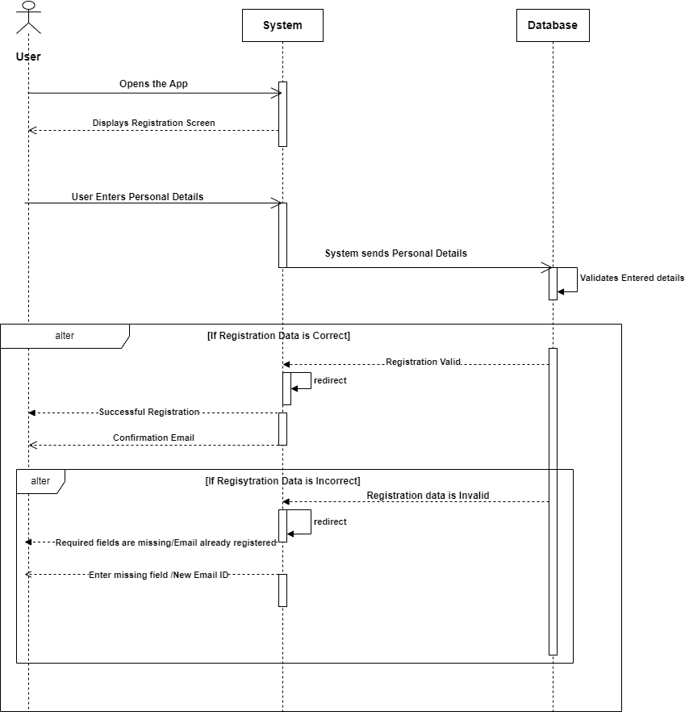

###### **Figure 4.13 Sequence Diagram – Registration**

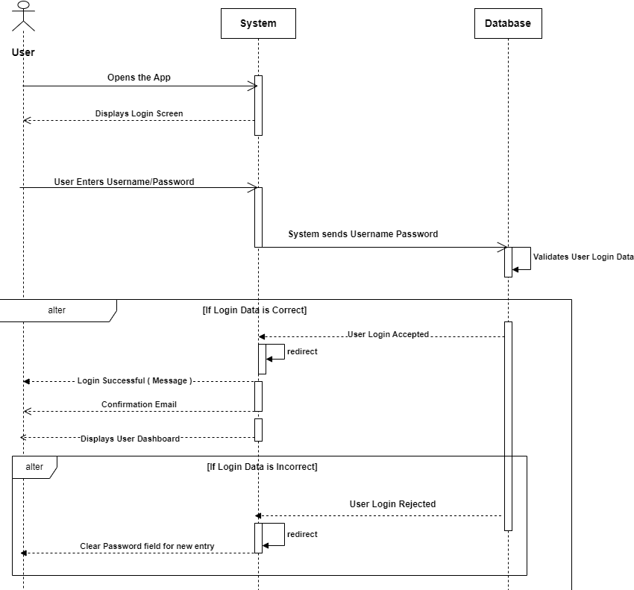

###### **Figure 4.14. Sequence Diagram - Login**

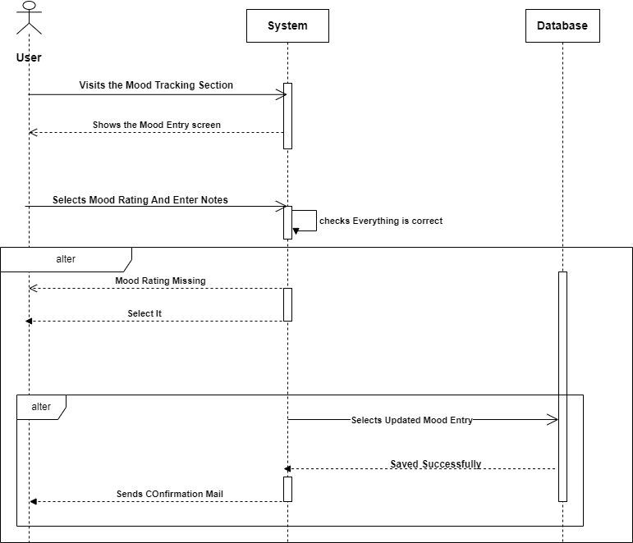

###### **Figure 4.15 Sequence Diagram – Mood Entry**

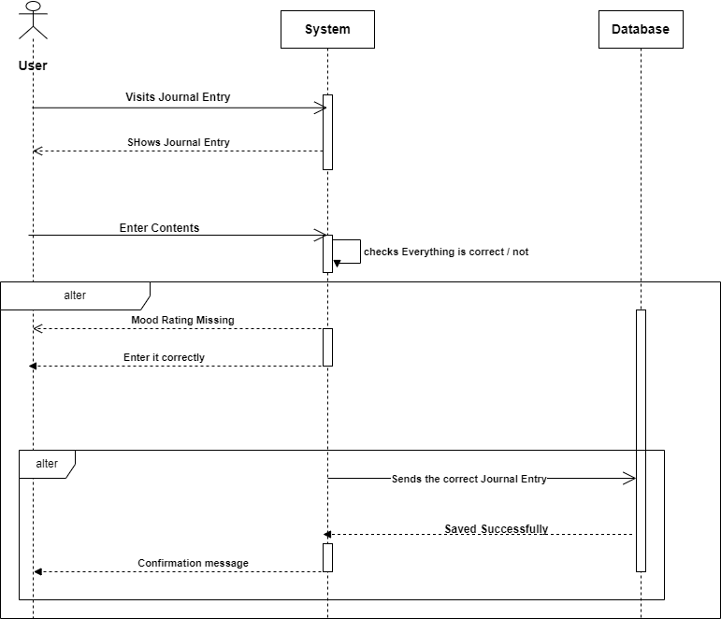

###### **Figure 4.16 Sequence Diagram – Record Journal Entry**

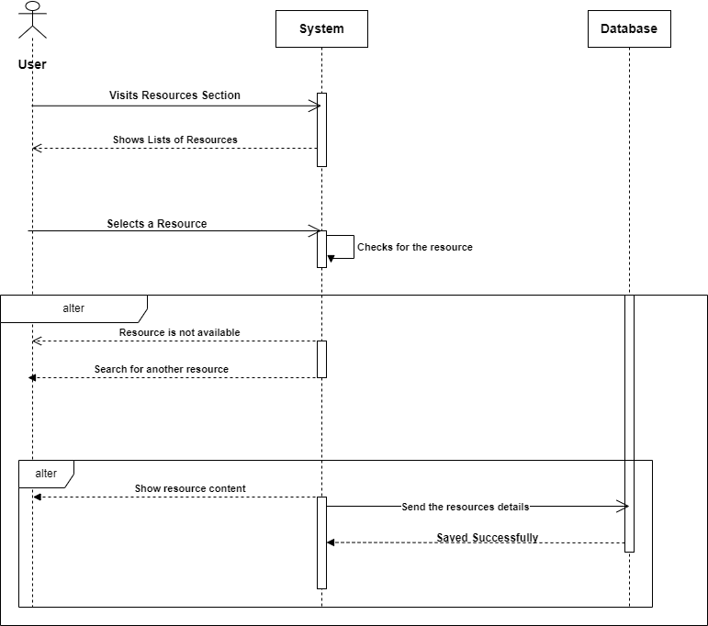

###### **Figure 4.17 Sequence Diagram – Access Resources**

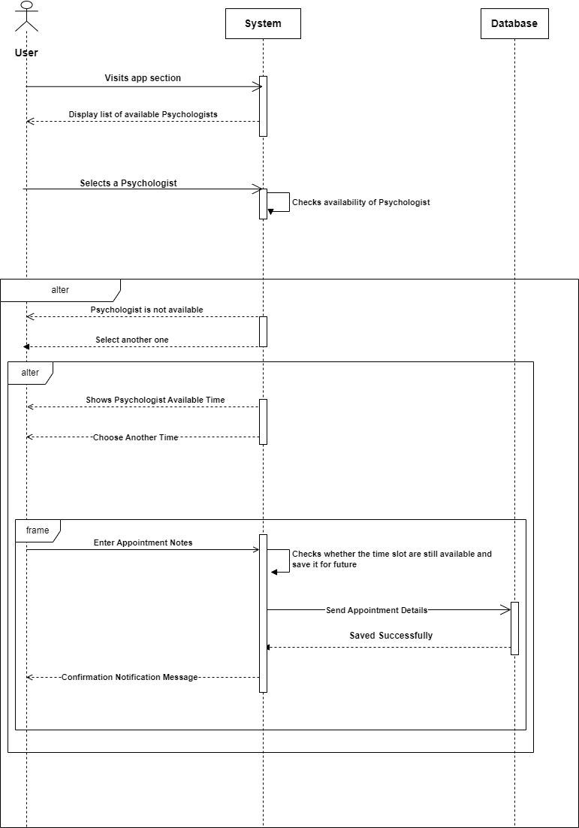

###### **Figure 4.18 Sequence Diagram – Book Appointment**

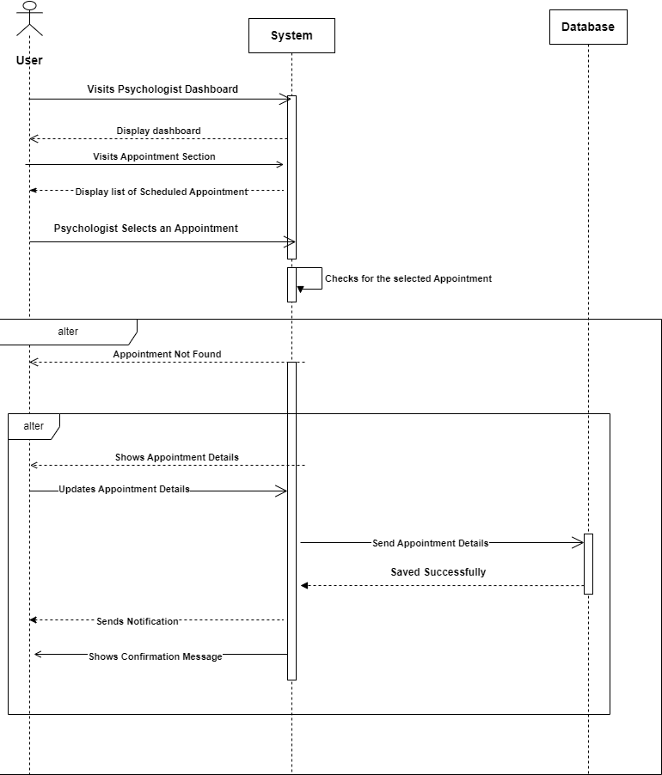

###### **Figure 4.19 Sequence Diagram – Psychologist manages Appointment**

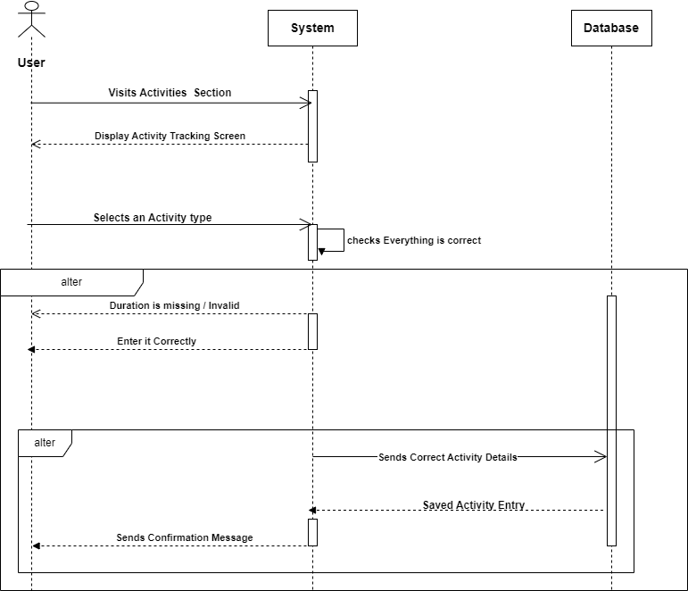

###### **Figure 4.20 Sequence Diagram – Track Activities**

## **4.8. Activity Diagram**

Activity diagram is another important diagram in UML to describe the dynamic aspects of the system. Activity diagram is basically a flowchart to represent the flow from one activity to another activity. The activity can be described as an operation of the system. The control flow is drawn from one operation to another. This flow can be sequential, branched, or concurrent. Activity diagrams deal with all type of flow control by using different elements such as fork, join, etc.

Symbol reference: <https://www.lucidchart.com/>

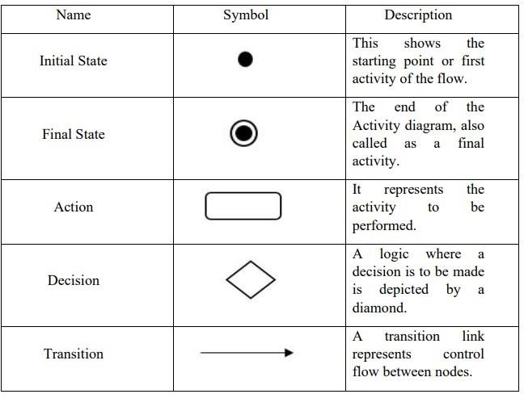

***Table 4.4. Activity Diagram Symbols***

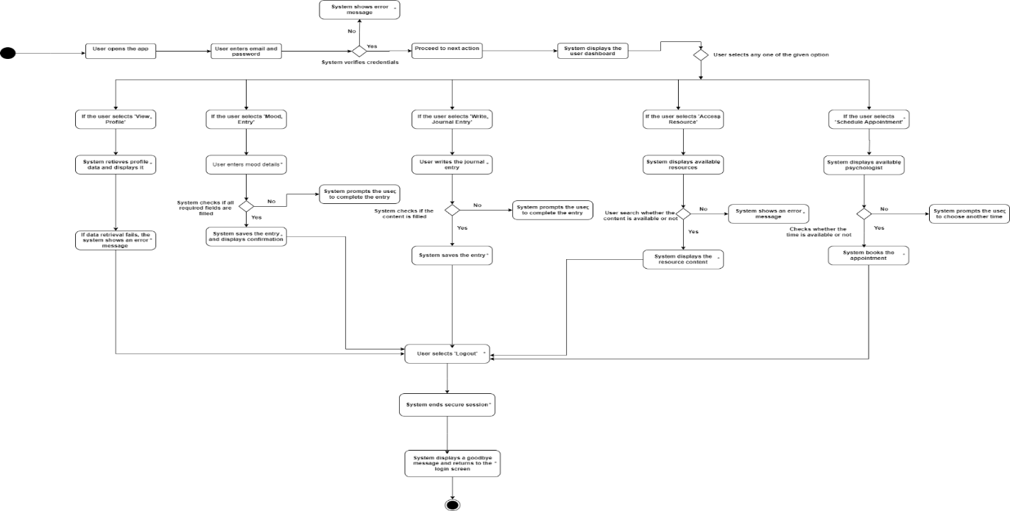

###### **Figure 4.21. Activity Diagram**

## **4.9. User Interface Design**

|  |  |
| --- | --- |
| **Figure 4.22. UI (Home Screen)** | **Figure 4.23. UI (Login and Signup)** |
| **Figure 4.24 UI (Mood and Activity Tracking)** | **Figure 4.25 UI (Meal Planning)** |
| **Figure 4.26 UI (Habit Tracking)** | **Figure 4.27 UI (Journal Tracking)** |
| **Figure 4.28 UI (Account Screen)** | **Figure 4.29 .UI (Profile page)** |
| **Figure 4.30. UI (Activity History)** | **Figure 4.31. UI (Record and Log Page)** |
| **Figure 4.32. UI (Games Screen)** | **Figure 4.33. UI (Mood Tracker Bingo)** |
| **Figure 4.34. UI (Mindful Breathing Screen)** | **Figure 4.35. UI (Therapeutic Word Search Game Screen)** |
| **Figure 4.36. UI (Affirmation Match Game)** | **Figure 4.37. UI (Gratitude Garden Game Screen)** |

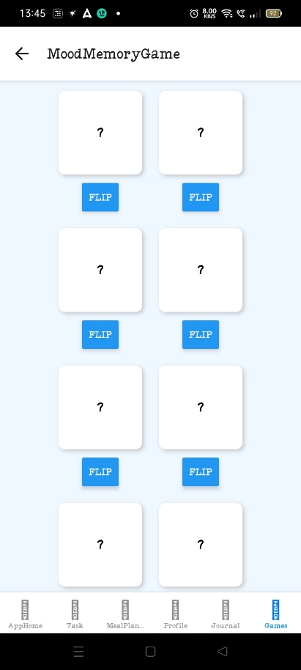

###### **Figure 4.38. UI (Mood Memory Game Screen)**

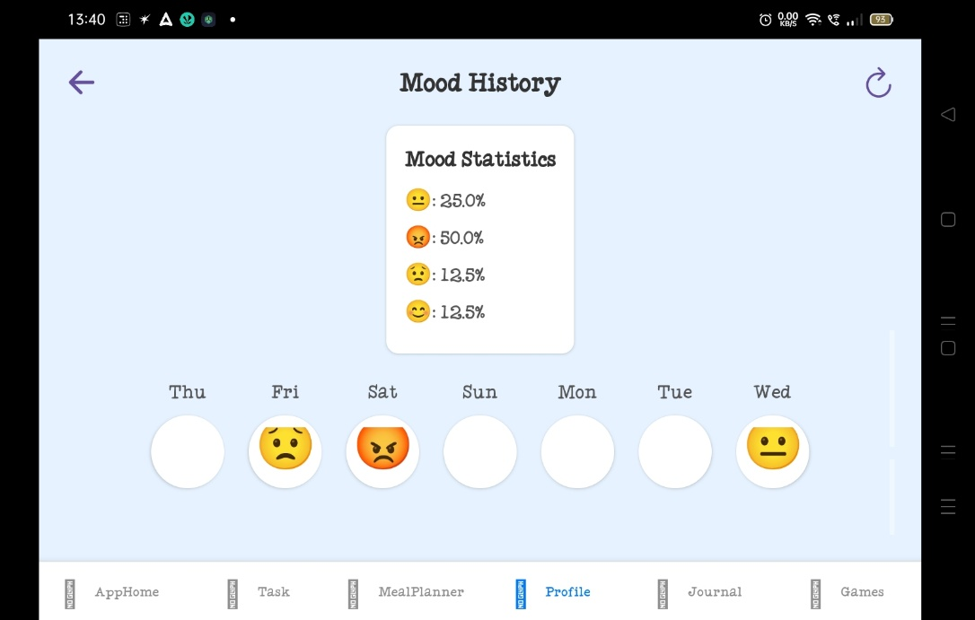

###### **Figure 4.39. UI (Mood History)**

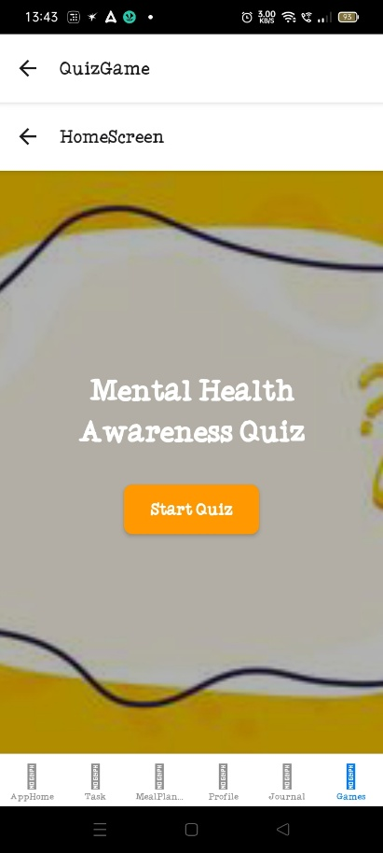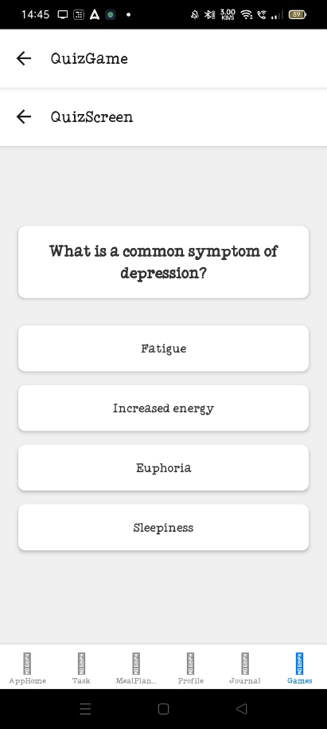 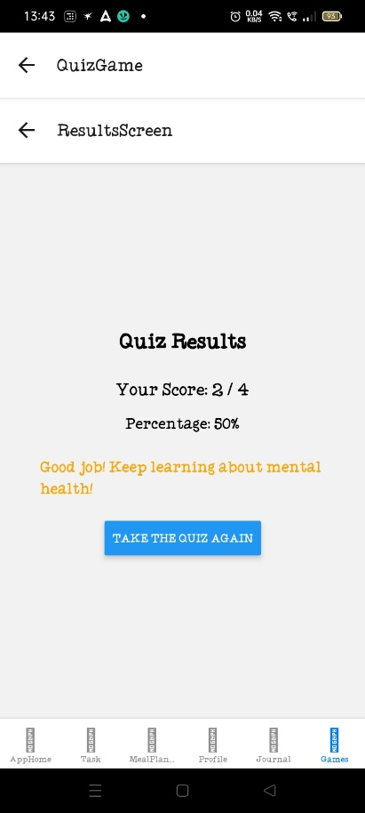

###### **Figure 4.40 UI (Quiz Home, Game and Result Screen)**

## **4.10. Test Case Design**

|  |  |  |  |  |
| --- | --- | --- | --- | --- |
| **Test Case NO.** | **Test Case Description** | **Expected Output** | **Actual Output** | **Remark** |
| 1 | Test Sign-Up process with valid inputs. Example: Username: abcd, Email: [abcd@gmail.com](mailto:abcd@gmail.com), Password: Pass1234, Mobile Number: 1234567890 | Validation for each field. Confirmation email/SMS received. |  |  |
| 2 | Test Sign-Up with an invalid email. Example: Email:ancd@com | Display error message: "Please enter a valid email address." |  |  |
| 3 | Test Sign-Up with invalid password length. Example: Password: Pass12 | Display error message: "Password must be at least 8 characters." |  |  |
| 4 | Test Login with valid credentials. Example: Email: [abcd@gmail.com](mailto:abcd@gmail.com), Password: Pass1234 | "Login Successful" message.Redirected to Home Screen. |  |  |
| 5 | Test Login with invalid credentials. Example: Email: [abcd@gmail.com](mailto:abcd@gmail.com), Password: WrongPass | Display error message: "Invalid credentials." |  |  |
| 6 | Test Mood Tracking feature. Example: Select Mood: Happy, Select Emoji: 😊 | "Mood Saved Successfully" message. Mood updated with selected emoji. |  |  |
| 7 | Test Activity Tracking - To-Do List. Example: Task: Finish Homework, Mark as completed | Task added to the To-Do List.Marking task as completed updates the status. |  |  |
| 8 | Test Water Intake Tracking. Example: Water Intake: 2 liters | Water intake data saved and displayed. |  |  |
| 9 | Test Save Tracking Data. Example: Mood: Happy, Activity: Meditation, Water Intake: 1.5L, Sleep: 8 hours | All data should be saved successfully. "Data Saved Successfully" message. |  |  |
| 10 | Test Personal Insight (Mood History). Example: View Mood Statistics | Mood statistics graph and Weekly Mood Circle displayed. |  |  |
| 11 | Test View Psychological Profile. Example: View Profile – abcd | Profile details (Username, Email, Phone, Bio, Profession) displayed with Edit Profile option. |  |  |
| 12 | Test View Goals (Activity Tracking History). Example: View Activity History | Activity Tracking History displayed (mood, tasks, water intake, etc.). |  |  |
| 13 | Test Records and Logs (Mood History - Pie Chart). Example: View Mood History | Pie Chart displaying Total Entries, Average Mood, Highest Mood, Lowest Mood. |  |  |
| 14 | Test Logout functionality. Example: Click "Logout" button | Redirected to Login page after successful logout. |  |  |
| 15 | Test Habit Tracker Screen (Error message displayed). Example: Try adding habit without being logged in | Display error: "No user token found. Please log in again." |  |  |
| 16 | Test Meal Planning Screen navigation and setting menu. Example: Set Menu for 01/01/2025: Breakfast: Pancakes, Lunch: Salad, Dinner: Soup | Menu options displayed for the selected date. Menu added successfully. |  |  |
| 17 | Test Meal Planning Screen (Delete Button not functional). Example: Try to delete menu item for 01/01/2025 | Display error or inactive Delete button. |  |  |
| 18 | Test Journal Tracking feature (not functional). Example: Try adding a journal entry | Display error: "Feature not functional due to technical issue." |  |  |
| 19 | Test Games Section - Quiz Game. Example: Start Quiz Game, Answer questions | Display results after completing the quiz. |  |  |
| 20 | Test Mood Tracker Bingo Game (select mood and get suggestion). Example: Mood: Sad, Get Suggestion: "Take a walk" | Mood selected and suggestion for improving mood displayed. |  |  |
| 21 | Test Therapeutic Word Search Game (find words within time limit). Example: Find "Calm", "Breathe" | List of found words displayed at the bottom. |  |  |
| 22 | Test Mindful Breathing Game. Example: Follow the breathing circle. | Circle expands and contracts to guide breathing. |  |  |
| 23 | Test Affirmation Match Game. Example: Flip cards, Match "Believe" and "In Yourself" | Cards flipped and matched successfully. |  |  |
| 24 | Test Gratitude Garden Game. Example: Add item "Health" to garden | Gratitude list grows as you add items, creating a virtual garden. |  |  |
| 25 | Test Mood Tracker Memory Game (match mood cards). Example: Match "Happy" and "Excited" | Moods matched and progress tracked successfully. |  |  |
| 26 | Test Habit Tracker Screen (Functional test for adding habits). Example: Try adding a habit like "Reading" | Habit added successfully to the tracker. |  |  |
| 27 | Test Habit Tracker Screen after logging in. Example: Log in and add habit "Exercise" | Habit added successfully and displayed in the tracker. |  |  |
| 28 | Test Journal Tracking feature (Create new journal entry). Example: Title: "My Day", Content: "Today was great." | Journal entry created and saved. |  |  |
| 29 | Test Journal Tracking feature (No input provided). Example: Try creating journal entry with empty fields | Display error message: "Title and content are required." |  |  |
| 30 | Test Journal Tracking feature with invalid input. Example: Title: "My Day", Content: Special characters like <> | Display error message: "Invalid input detected." |  |  |

***Table: 4.5. Test Case Table***

# **Chapter 5: Implementation and testing**

## **5.1. Implementation Approaches**

The Mental Health and Wellbeing App was built with a clear and organized approach to ensure it worked well, was easy to use, and followed best practices. Here’s a simplified breakdown of how it was done:

1. **Choosing the Right Technology**

* **Frontend (User Interface)**: React Native was used to build the app, making it work on both iOS and Android phones.
* **Backend (Server)**: Node.js and Express.js were used to handle the app's server and API .
* **Database**: MongoDB was used to store and manage data, with Mongoose to help structure it.
* **Authentication (Login Security)**: JWT (JSON Web Tokens) were used to securely manage user login and keep information safe.
* **State Management**: React’s Context API and Redux helped manage and track data that needed to be shared across the app.
* **Version Control**: Git and GitHub were used to keep track of changes made to the code.

2. **Implementation Standards**

* **Coding Standards**: The app used modern JavaScript (ES6+) to keep the code clean, easy to read, and maintainable.
* **UI/UX**: The app’s design followed Material Design principles, which means it’s easy to navigate and looks good on all devices.
* **Testing**:
  + **Unit Testing**: Individual parts of the app were tested to make sure each one worked properly.
  + **API Testing**: The app’s server and data requests were tested to ensure they were secure and performed well (using Postman).
  + **Manual Testing**: The app was tested by hand on an Android emulator to make sure everything worked as expected, including on different screen sizes and ensuring the app was easy to use.

## **5.2. Coding Details and Code Efficiency**

**1. Data Models (MongoDB with Mongoose)**

The app follows a structured NoSQL database design with MongoDB, using Mongoose schemas to model data effectively.

**Example: Mood Tracking Schema**

const mongoose = require('mongoose');

const moodSchema = new mongoose.Schema({

userEmail: { type: String, required: true }, // Store email directly for user association

mood: { type: String, enum: ['😡', '😟', '😐', '😊', '😌'], required: true },

note: { type: String, maxlength: 500 }, // Optional note entry

createdAt: { type: Date, default: Date.now } // Auto timestamp

});

module.exports = mongoose.model('Mood', moodSchema);

**Efficiency:**

* Used fixed mood emojis for consistent data.
* Indexed the email for quicker searches.
* Added automatic timestamps for easy tracking.

**2. Backend (Node.js + Express.js)**

The backend is structured with RESTful APIs to handle authentication, user data, and tracking.

Example: User Authentication API (Signup & Login)

const bcrypt = require("bcryptjs");

const jwt = require("jsonwebtoken");

// User signup route

app.post("/signup", async (req, res) => {

const { name, email, password, phone } = req.body;

// Validate email format

if (!email || !emailRegex.test(email)) {

return res.status(400).send({ message: "Invalid email format" });

}

// Check if user exists

const oldUser = await user.findOne({ email });

if (oldUser) return res.status(400).send({ message: "User already exists" });

// Hash password

const hashedPassword = await bcrypt.hash(password, 10);

await user.create({ name, email, password: hashedPassword, phone });

res.send({ message: "User created successfully" });

});

// User login route

app.post("/login", async (req, res) => {

const { email, password } = req.body;

const userFound = await user.findOne({ email });

if (!userFound) return res.status(400).send({ message: "User doesn't exist" });

if (await bcrypt.compare(password, userFound.password)) {

const token = jwt.sign({ email: userFound.email, userId: userFound._id }, JWT_SECRET);

return res.send({ token });

} else {

return res.status(400).send({ message: "Invalid password" });

}

});

**Efficiency:**

* Password Hashing with bcrypt to enhance security.
* Token-based authentication (JWT) for secure API access.
* Input validation for preventing incorrect or missing fields.

**3. Middleware: JWT Authentication**

const verifyToken = (req, res, next) => {

const token = req.headers['authorization']?.split(' ')[1];

if (!token) return res.status(403).json({ error: 'No token provided' });

jwt.verify(token, JWT_SECRET, (err, decoded) => {

if (err) return res.status(401).json({ error: 'Unauthorized' });

req.user = decoded; // Store user data in request

next();

});

};

**Efficiency:**

* Protects the API by requiring valid tokens for access.
* Middleware makes it easy to use the same logic across multiple routes.

**4. Frontend (React Native + Context API)**

The app uses React Native with hooks and Context API for global state management.

**Example: Mood Tracking Component**

const handleEmojiClick = async (mood) => {

try {

console.log('Selected Mood:', mood);

await saveMood(mood); // Save to backend

setMood(mood); // Update UI state

} catch (error) {

console.error('Error saving mood:', error);

}

};

return (

<View>

{['😡', '😟', '😐', '😊', '😌'].map((emoji) => (

<TouchableOpacity key={emoji} onPress={() => handleEmojiClick(emoji)}>

<Text>{emoji}</Text>

</TouchableOpacity>

))}

</View>

);

**Efficiency:**

* Used hooks (useState) to manage the mood state.
* Reduced unnecessary updates by changing the mood only when needed.

**5. Optimized API Calls (Fetching Data Efficiently)**

**Example: Fetching Mood History**

const fetchMoodHistory = async () => {

try {

const token = await AsyncStorage.getItem('token');

if (!token) return alert('User not logged in!');

const response = await axios.get('https://mentalapp-backend.onrender.com/moods/history', {

headers: { Authorization: `Bearer ${token}` },

});

if (response.status === 200) {

setMoodHistory(response.data.moodHistory);

} else {

alert('No mood history found.');

}

} catch (error) {

console.error('Error fetching mood history:', error);

}

};

**Efficiency:**

* Used local storage (AsyncStorage**)** to manage login sessions.
* Handled API errors gracefully to prevent crashes.
  1. **Habit Tracking Feature (Backend & API)**

This module allows users to create, update, delete, and track habits over time.

**Habit Model (MongoDB Schema)**

const mongoose = require('mongoose');

const habitSchema = new mongoose.Schema({

userId: { type: mongoose.Schema.Types.ObjectId, ref: 'User', required: true },

name: { type: String, required: true },

completed: { type: Boolean, default: false },

streak: { type: Number, default: 0 },

createdAt: { type: Date, default: Date.now }

});

const Habit = mongoose.model('Habit', habitSchema);

module.exports = Habit;

**Efficiency:**

* Embedded Streak Counter**:** Tracks consecutive habit completion to improve engagement.
* User ID Reference**:** Links habits to users without duplicating data.

**API Routes for Habit Management**

1. **Add a New Habit**

app.post('/api/habits', async (req, res) => {

const { userId, name } = req.body;

try {

const newHabit = new Habit({ userId, name });

await newHabit.save();

res.status(201).json({ message: "Habit added successfully", habit: newHabit });

} catch (error) {

res.status(500).json({ error: "Failed to add habit" });

}

});

1. **Update Habit Completion**

app.put('/api/habits/:habitId', async (req, res) => {

try {

const { habitId } = req.params;

const habit = await Habit.findById(habitId);

if (!habit) return res.status(404).json({ error: "Habit not found" });

habit.completed = !habit.completed;

habit.streak = habit.completed ? habit.streak + 1 : 0; // Reset streak if unchecked

await habit.save();

res.json({ message: "Habit updated", habit });

} catch (error) {

res.status(500).json({ error: "Failed to update habit" });

}

});

**Efficiency:**

* Toggle Completion in One API Call → No need to send a separate API request for marking habits as completed.
* Streak Logic Built-in → Increases or resets automatically.
  1. **Meal Planning Module (Optimized for Fast Access)**

Allows users to plan meals for each day and fetch previous meal plans.

**Meal Planning Schema (MongoDB)**

const mongoose = require('mongoose');

const mealSchema = new mongoose.Schema({

userId: { type: mongoose.Schema.Types.ObjectId, ref: 'User', required: true },

date: { type: String, required: true }, // Stores meals by date

meals: [

{

mealType: { type: String, enum: ['Breakfast', 'Lunch', 'Dinner'], required: true },

items: [{ type: String, required: true }]

}

],

});

const Meal = mongoose.model('Meal', mealSchema);

module.exports = Meal;

**Efficiency:**

* Indexed by userId and date → Allows fast retrieval of meal plans.
* Embedded meal list → Stores all meals in a single document for quick queries.

**API Routes for Meal Planning**

**1️. Add a New Meal Plan**

app.post('/api/meals', async (req, res) => {

const { userId, date, meals } = req.body;

try {

const newMealPlan = new Meal({ userId, date, meals });

await newMealPlan.save();

res.status(201).json({ message: "Meal plan added successfully", mealPlan: newMealPlan });

} catch (error) {

res.status(500).json({ error: "Failed to add meal plan" });

}

});

**2️. Get Meals for a Specific Date**

app.get('/api/meals/:userId/:date', async (req, res) => {

try {

const { userId, date } = req.params;

const meals = await Meal.findOne({ userId, date });

if (!meals) return res.status(404).json({ message: "No meal plan found for this date" });

res.json(meals);

} catch (error) {

res.status(500).json({ error: "Failed to fetch meals" });

}

});

## **5.3. Code Efficiency**

**1. Speeding Up Database Searches with Indexing**

By creating indexes on important fields in the database, search queries become faster, improving login and data retrieval times.

**Example Code**:

const userSchema = new mongoose.Schema({

email: { type: String, required: true, unique: true, index: true }, // Indexed for faster lookup

password: { type: String, required: true },

});

* 1. **Loading Data in Small Chunks to Improve Performance**:

Instead of loading all data at once, we fetch only a limited amount of data per request. This reduces server load and keeps the app responsive.

**Example Code**:

app.get("/api/journals", async (req, res) => {

const page = parseInt(req.query.page) || 1;

const limit = 10;

const journals = await Journal.find({ userId: req.user.id })

.skip((page - 1) * limit)

.limit(limit);

res.json(journals);

});

**3. Using Tokens for Faster and Secure Logins:**

JWT (JSON Web Tokens) are used to verify users, removing the need to query the database for every request, which makes the app faster and more scalable.

**Example Code**:

const verifyToken = (req, res, next) => {

const token = req.headers["authorization"]?.split(" ")[1];

if (!token) return res.status(403).json({ error: "No token provided" });

jwt.verify(token, JWT_SECRET, (err, decoded) => {

if (err) return res.status(401).json({ error: "Unauthorized" });

req.user = decoded;

next();

});

};

**4. Avoiding Unnecessary Data Requests with Local Storage**

Storing frequently accessed data locally (using Context API or local storage) prevents making unnecessary API calls, making the app more responsive.

**Example Code**:

export const UserProvider = ({ children }) => {

const [user, setUser] = useState(null);

const fetchUser = async () => {

const token = await AsyncStorage.getItem("token");

const res = await axios.get("/api/user", { headers: { Authorization: `Bearer ${token}` } });

setUser(res.data);

};

return <UserContext.Provider value={{ user, fetchUser }}>{children}</UserContext.Provider>;

};

**5. Improving Performance Across Features**

Using strategies like JWT for faster logins, pagination for large data, and background processing for tasks helps make the app more efficient and responsive.

**6. Reducing Network Requests by Storing Data Locally**

Storing session data locally (such as login tokens) helps reduce network calls, speeding up the app and saving on server resources.

**Example Code**:

const storeToken = async (token) => {

await AsyncStorage.setItem("authToken", token);

};

## **5.4. Testing Approach**

The testing approach followed a clear method to ensure the app works correctly in all situations. The strategy includes:

**1. Functional Testing**

This testing checks if each feature works as expected:

* **Unit Testing**: Tests individual features like login, mood tracking, and activities separately.
* **Integration Testing**: Ensures that different features (like login and mood tracking) work well together.
* **Performance Testing**: Measures how fast the app works and checks stability under heavy use.
* **Security Testing**: Ensures the app's security, like checking user login and protecting data.

**2. User Acceptance Testing (UAT)**

This testing ensures the app is easy to use and works well for real users:

* Tested how easy it is for users to navigate and use the app.
* Verified that the design and navigation are consistent.
* Ensured all features are usable without bugs.
* Tested the app on different devices (phones and tablets).
* Checked that error messages appear correctly when users make mistakes.

This approach helps ensure the app is functional, secure, and user-friendly.

## **5.5. Unit Testing**

Unit testing was conducted on each individual module to validate its functionality, reliability, and correctness.

* Testing Scope
* **Authentication:** Verified user registration, login, and session management.
* **Mood Tracking:** Ensured mood selection and storage were accurate.
* **Activity Tracking:** Checked to-do lists, water intake, and sleep tracking functionality.
* **Game Module:** Validated game interactions and progress tracking.
* **Journal Module:** Tested saving and retrieving journal entries.
* Example of Unit Test Cases

### **5.5.1. Authentication Module**

|  |  |  |  |  |
| --- | --- | --- | --- | --- |
| **Test Case No.** | **Test Case Description** | **Expected Output** | **Actual Output** | **Remark** |
| 1 | Test Sign-Up process with valid inputs. Example: Username: abcd, Email: [abcd@gmail.com](mailto:abcd@gmail.com), Password: Pass1234, Mobile Number: 1234567890 | Validation for each field. Confirmation email/SMS received. | Successful Sign-Up with validation checks and confirmation received. | All steps function as expected. |
| 2 | Test Login with valid credentials. Example: Email: [abcd@gmail.com](mailto:abcd@gmail.com), Password: Pass1234 | "Login Successful" message. Redirected to Home Screen. | Login successful, Home Screen displayed. | Login functioning correctly. |
| 3 | Test Login with invalid credentials. Example: Email: [abcd@gmail.com](mailto:abcd@gmail.com), Password: WrongPass | Display error message: "Invalid credentials." | Error message "Invalid credentials." | Login error handled properly. |

***Table 5.1. Authentication test cases***

### **5.5.2. Mood Tracking Module**

|  |  |  |  |  |
| --- | --- | --- | --- | --- |
| **Test Case No.** | **Test Case Description** | **Expected Output** | **Actual Output** | **Remark** |
| 4 | Test Mood Tracking feature. Example: Select Mood: Happy, Select Emoji: 😊 | "Mood Saved Successfully" message. Mood updated with selected emoji. | Mood saved successfully and emoji updated. | Mood tracking works correctly. |
| 5 | Test Save Tracking Data. Example: Mood: Happy, Activity: Meditation, Water Intake: 1.5L, Sleep: 8 hours | All data should be saved successfully. "Data Saved Successfully" message. | All data saved successfully. Message "Data Saved Successfully." | Data save process completed correctly. |
| 6 | Test Personal Insight (Mood History). Example: View Mood Statistics | Mood statistics graph and Weekly Mood Circle displayed. | Mood history and statistics displayed as expected. | Insight feature works as intended. |
| 7 | Test Records and Logs (Mood History - Pie Chart). Example: View Mood History | Pie Chart displaying Total Entries, Average Mood, Highest Mood, Lowest Mood. | Mood history displayed in Pie Chart correctly. | Pie chart shows expected mood data. |
| 8 | Test Mood Tracker Bingo Game (select mood and get suggestion). Example: Mood: Sad, Get Suggestion: "Take a walk" | Mood selected and suggestion for improving mood displayed. | Mood selected, suggestion provided. | Bingo game delivers proper suggestions. |
| 9 | Test Mood Tracker Memory Game (match mood cards). Example: Match "Happy" and "Excited" | Moods matched and progress tracked successfully. | Memory game worked as expected with moods matched. | Memory game features operate as planned. |

***Table 5.2. Mood Tracking test Cases***

### **5.5.3. Meal Planning Module**

|  |  |  |  |  |
| --- | --- | --- | --- | --- |
| **Test Case No.** | **Test Case Description** | **Expected Output** | **Actual Output** | **Remark** |
| 10 | Test Create Meal Plan. Example: {userId: "12345", date: "2025-02-26", meals: [...]} | Meal plan saved | Data stored in DB | Pass |
| 11 | Test Meal Planning Screen navigation and setting menu. Example: Set Menu for 01/01/2025: Breakfast: Pancakes, Lunch: Salad, Dinner: Soup | Menu options displayed for the selected date. Menu added successfully. | Menu added successfully for the selected date. | Meal planning navigation functions well. |
| 12 | Test Meal Planning Screen (Delete Button not functional). Example: Try to delete menu item for 01/01/2025 | Display error or inactive Delete button. | Delete button is inactive as expected due to backend error. | Delete function not operational, error present. |
| 13 | Test Delete Meal Plan. Example: {userId: "12345", date: "2025-02-26"} | Meal plan deleted successfully | Error while deleting meal | **Fail** |

***Table 5.3. Meal Planning test cases***

### **5.5.4. User Management**

|  |  |  |  |  |
| --- | --- | --- | --- | --- |
| **Test Case No.** | **Test Case Description** | **Expected Output** | **Actual Output** | **Remark** |
| 14 | Test Update User Profile. Example: {userId: "12345", name: "John Doe", bio: "Mental health advocate"} | Profile updated successfully | Profile changes saved correctly | Pass |
| 15 | Test Fetch Updated User Profile after Update. Example: {userId: "12345"} | Fetches updated profile details (Name, Bio, etc.). | Profile is updated but not fetched correctly. | **Fail** — The updated profile is not being fetched after the update. This issue needs to be investigated in the fetching API or database syncing. |

***Table 5.4. User Management test Cases***

### **5.5.5. Journal Module**

|  |  |  |  |  |
| --- | --- | --- | --- | --- |
| **Test Case No.** | **Test Case Description** | **Expected Output** | **Actual Output** | **Remark** |
| 16 | Test Journal Tracking feature (Create new journal entry). Example: Title: "My Day", Content: "Today was great." | Journal entry created and saved. | (Feature not functional, error message: "Feature not functional due to technical issue.") | **Fail** |
| 17 | Test Journal Tracking feature (No input provided). Example: Try creating journal entry with empty fields | Display error message: "Title and content are required." | (Feature not functional, error message: "Feature not functional due to technical issue.") | **Fail** |
| 18 | Test Journal Tracking feature with invalid input. Example: Title: "My Day", Content: Special characters like <> | Display error message: "Invalid input detected." | (Feature not functional, error message: "Feature not functional due to technical issue.") | **Fail** |

***Table 5.5. Journal test cases***

### **5.5.6. Habit Tracker Module**

|  |  |  |  |  |
| --- | --- | --- | --- | --- |
| **Test Case No.** | **Test Case Description** | **Expected Output** | **Actual Output** | **Remark** |
| 19 | Test Habit Tracker Screen (Functional test for adding habits). Example: Try adding a habit like "Reading" | Habit added successfully to the tracker. | (Feature not functional, error message: "No user token found. Please log in again.") | **Fail** |
| 20 | Test Habit Tracker Screen after logging in. Example: Log in and add habit "Exercise" | Habit added successfully and displayed in the tracker. | (Feature not functional, error message: "No user token found. Please log in again.") | **Fail** |

***Table 5.6. Habit Tracker test cases***

### **5.5.7. Reminder System Module**

|  |  |  |  |  |
| --- | --- | --- | --- | --- |
| **Test Case No.** | **Test Case Description** | **Expected Output** | **Actual Output** | **Remark** |
| 21 | Test Save Reminder. Example: {userId: "12345", reminderTime: "08:00 AM"} | Reminder saved successfully | Error | **Fail** |

***Table 5.7. Reminder test cases***

### **5.5.8. Activity Tracking Module**

|  |  |  |  |  |
| --- | --- | --- | --- | --- |
| **Test Case No.** | **Test Case Description** | **Expected Output** | **Actual Output** | **Remark** |
| 22 | Test Water Intake Tracking. Example: Water Intake: 2 liters | Water intake data saved and displayed. | Water intake data saved correctly. | Water tracking is functioning. |
| 23 | Test Activity Tracking - To-Do List. Example: Task: Finish Homework, Mark as completed | Task added to the To-Do List. Marking task as completed updates the status. | Task added and marked completed. | To-Do list working as expected. |
| 24 | Test View Goals (Activity Tracking History). Example: View Activity History | Activity Tracking History displayed (mood, tasks, water intake, etc.). | Activity Tracking History displayed correctly. | History of activities displayed without issues. |

***Table 5.8. Activity Tracking test cases***

### **5.5.9. Game Module**

|  |  |  |  |  |
| --- | --- | --- | --- | --- |
| **Test Case No.** | **Test Case Description** | **Expected Output** | **Actual Output** | **Remark** |
| 25 | Test Games Section - Quiz Game. Example: Start Quiz Game, Answer questions | Display results after completing the quiz. | Quiz game worked as expected, showing final results. | Quiz game operates correctly. |
| 26 | Test Therapeutic Word Search Game (find words within time limit). Example: Find "Calm", "Breathe" | List of found words displayed at the bottom. | Words found within time limit, progress displayed. | Game works within time constraints. |
| 27 | Test Mindful Breathing Game. Example: Follow the breathing circle. | Circle expands and contracts to guide breathing. | Breathing exercise worked as expected with the circle timing. | Breathing game functionality verified. |
| 28 | Test Affirmation Match Game. Example: Flip cards, Match "Believe" and "In Yourself" | Cards flipped and matched successfully. | Cards matched and pairs found as expected. | Game interaction and matching function properly. |
| 29 | Test Gratitude Garden Game. Example: Add item "Health" to garden | Gratitude list grows as you add items, creating a virtual garden. | Gratitude garden updated with each item. | Garden grows with each added entry. |

***Table 5.9. Games test cases***

## **5.6. Integrated Testing**

* **Testing Focus**
* **Making Modules Work Together**: Ensured authentication, tracking, and games work well together.
* **Keeping Data Consistent**: Verified data stays the same between user sessions.
* **Keeping Users Logged In**: Checked that users stay logged in while using different features.
* **Ensuring Smooth Communication**: Made sure the app’s frontend and backend work together properly.

This ensures that everything in the app runs smoothly and works together without problems.

* Sample Integration Test Case

### **5.6.1. User Management - Profile Update and Fetch Integration**

Test Case Description: Verify the complete workflow of profile updates and fetching updated profile details.

|  |  |  |  |  |  |
| --- | --- | --- | --- | --- | --- |
| **Test Case No.** | **Modules Involved** | **Input** | **Expected Output** | **Actual Output** | **Remark** |
| 30 | Authentication, User Management | {email: "[abcd@gmail.com](mailto:abcd@gmail.com)", password: "Test1234"} | Returns JWT token, Fetches user profile | JWT generated, Profile retrieved | Pass |
| 31 | Authentication, User Management | {userId: "12345", name: "Abcd", bio: "Mental health advocate"} | Profile updated, Changes visible on reload | Profile changes saved, Visible on reload | Pass |
| 32 | Authentication, User Management | {userId: "12345"} | Profile update reflected on fetch | Profile update fetched correctly | Pass |

***Table 5.10. User Management - Profile Update and Fetch Integration***

**Remark**: All steps pass except for fetching the updated profile after modification (potential sync issue).

### **5.5.2. Authentication & Profile Update Integration**

Test Case Description: Test if a user can log in, update their profile, and fetch the updated profile seamlessly.

|  |  |  |  |  |  |
| --- | --- | --- | --- | --- | --- |
| Test Case No. | Modules Involved | Input | Expected Output | Actual Output | Remark |
| 33 | Authentication, User Management | {email: "test@example.com", password: "Test1234"}, {userId: "12345", name: "Jane Doe", bio: "Mental health advocate"} | User login, profile updated, and fetched correctly | Profile updated, Fetched correctly | Pass |

***Table 5.11. Authentication & Profile Update Integration***

**Remark**: All steps pass successfully, indicating proper integration of authentication and profile updates.

### **5.5.3. Mood Tracking & Profile Fetch Integration**

Test Case Description: Test the ability to submit mood and fetch mood history

|  |  |  |  |  |  |
| --- | --- | --- | --- | --- | --- |
| Test Case No. | Modules Involved | Input | Expected Output | Actual Output | Remark |
| 34 | Authentication, Mood Tracking | {userEmail: "test@example.com", mood: "😊"} | Mood saved, Latest mood fetched | Mood recorded, Latest mood retrieved | Pass |

***Table 5.12. Mood Tracking & Profile Fetch Integration***

**Remark**: Successfully tests mood tracking and history fetching.

### **5.5.4. Habit Tracker and stats Integration**

Test Case Description: Ensure habit tracking is working and stats are correctly updated.

|  |  |  |  |  |  |
| --- | --- | --- | --- | --- | --- |
| Test Case No. | Modules Involved | Input | Expected Output | Actual Output | Remark |
| 35 | Authentication, Habit Tracker | {userId: "67890", habit: "Exercise"} | Habit saved, Stats updated correctly | Error | Fail |

***Table 5.13. Habit Tracker and stats Integration***

**Remark**: Habit tracking integration fails, needs debugging.

### **5.5.5. Meal Planning-Creation and Deletion**

Test Case Description: Verify that meal plans can be created and deleted successfully.

|  |  |  |  |  |  |
| --- | --- | --- | --- | --- | --- |
| Test Case No. | Modules Involved | Input | Expected Output | Actual Output | Remark |
| 36 | Authentication, Meal Planning | {userId: "12345", date: "2025-02-26", meals: [...]}, Delete {userId: "12345", date: "2025-02-26"} | Meal saved, Later deleted | Meal saved, Deletion failed | Fail |

***Table 5.14. Meal Planning-Creation and Deletion***

**Remark**: Deletion fails after creation, likely an issue with delete functionality

### **5.5.6. Journal Module-Save and retrieve Integration**

Test Case Description: Test the creation and retrieval of journal entries.

|  |  |  |  |  |  |
| --- | --- | --- | --- | --- | --- |
| Test Case No. | Modules Involved | Input | Expected Output | Actual Output | Remark |
| 37 | Authentication, Journal Module | {userId: "12345", title: "My Thoughts", content: "Feeling great!"} | Journal saved, Retrieved successfully | Error while fetching journal | Fail |

***Table 5.15. Journal Module-Save and retrieve Integration***

**Remark**: Issue with fetching journal entries from the database after creation.

### **5.5.7. Logout and Token Expiry**

Test Case Description: Test that after logging out, the token is invalidated, and the user is logged out successfully.

|  |  |  |  |  |  |
| --- | --- | --- | --- | --- | --- |
| Test Case No. | Modules Involved | Input | Expected Output | Actual Output | Remark |
| 38 | Authentication | Logout request with valid JWT token | Token invalidated, User logged out | Token invalidated correctly | Pass |

***Table 5.16. Logout and Token Expiry***

**Remark**: Logout works as expected, and token invalidation is handled correctly.

### **5.5.8. Meal Plan Retrieval**

Test Case Description: Ensure meal plans are saved and retrieved successfully.

|  |  |  |  |  |  |
| --- | --- | --- | --- | --- | --- |
| Test Case No. | Modules Involved | Input | Expected Output | Actual Output | Remark |
| 39 | Meal Planning, User Management | {userId: "12345", date: "2025-02-27", meals: [...]}, Retrieve meal plan for date "2025-02-27" | Meal saved, Retrieved correctly | Meal saved, Fetched successfully | Pass |

***Table 5.17. Meal Plan Retrieval***

**Remark**: Meal plans are being correctly saved and retrieved.

### **5.5.9. Track Water Intake and Reports**

Test Case Description: Test the water intake tracking and ensure data is reflected in reports.

|  |  |  |  |  |  |
| --- | --- | --- | --- | --- | --- |
| Test Case No. | Modules Involved | Input | Expected Output | Actual Output | Remark |
| 40 | Tracking, User Management | {userId: "12345", waterIntake: 8} | Data saved, Reflected in reports | Water intake recorded correctly | Pass |

***Table 5.18. Track Water Intake and Reports***

**Remark**: Water intake functionality is working correctly.

## **5.6. Modifications and Improvements**

During testing, **various issues were identified and resolved**, leading to enhanced **performance, security, and user experience**.

|  |  |  |  |
| --- | --- | --- | --- |
| **Issue** | **What I did to fix it?** | **Example** | **Improvement** |
| Slow API response time | Added indexes to important fields in MongoDB. | Searching for a user’s mood history became faster. | Queries are quicker. |
| Session expiry not handled | Fixed how JWT expiration is managed. | Users stay logged in until the token expires. | Login is more secure. |
| Unresponsive UI during data fetch | Added loading indicators while data loads. | Shows a "loading..." message when fetching data. | Better user experience. |
| Error handling in input forms | Improved error messages for missing or incorrect inputs. | Shows clear messages if a user forgets to fill out a field. | Users get better feedback. |
| Game data not updating | Fixed caching issues in the game module. | Game scores update instantly without delay. | Instant updates to game data. |
| Limited game variety | Added more engaging games focused on relaxation. | New games like "breathing exercises" and "mindfulness puzzles" are now available. | More interactive features. |
| Users submitting multiple moods | Overwrote previous mood entry instead of allowing duplicates. | A user can only have one mood per day now. | Cleaner and more accurate mood tracking. |
| Meal plan deletion issue | Fixed API to allow meal plan removal on a selected date. | Users can now delete meal plans for specific days. | More control over meal plans. |
| Profile updates not saving | Ensured backend correctly saves and validates profile changes. | Users can now edit their name and bio successfully. | Profile management is reliable. |
| Data inconsistency in reports | Standardized data storage format across modules. | Mood history and meal plans now sync properly. | More accurate and consistent reports. |
| Meal deletion not working | Still working on fixing the meal deletion issue. | Meal plans still can't be deleted as expected. | Issue remains unresolved. |
| Profile not updated on UI | Still working on fixing profile update display. | Profile changes are not reflecting immediately on the UI. | Issue remains unresolved. |
| Habit tracker error | Fixed authentication check in habit tracker. | Habit tracker shows error "user not authenticated" despite being logged in. | Fixed user authentication issue. |
| Journal entry not added | Fixed API issue with saving journal entries. | Journal entries are not saved and show an error. | Journal entries now saved properly. |

***Table 5.19 Modification and Improvement Table***

# **Chapter 6: Results and Discussions**

## **Test Report**

Test Case Reports for Mental Health and Wellbeing App

The testing process for this app focused on ensuring that all features worked correctly and securely. Key areas tested included Functional Testing, User Acceptance Testing (UAT), and Unit Testing, covering modules such as Authentication, Mood Tracking, Activity Tracking, Meal Planning, Journal Management, and Habit Tracking. Most modules passed their tests, confirming that features like sign-up, login, mood tracking, and activity tracking worked as expected. However, some issues were found, such as problems with meal deletions, journal entry saving, and habit tracking due to missing user authentication.

Integration testing ensured that different app features worked well together. For example, the User Management and Profile Update modules mostly worked fine, but there were issues with fetching updated profiles after changes. Similarly, while Mood Tracking and Profile Fetching worked well, other features like Meal Planning and Journal Management had syncing issues.

During testing, we also made improvements to the app, such as speeding up API responses, improving security with better session handling, and enhancing the user interface by adding loading indicators and clearer error messages. However, some problems, like meal plan deletion and profile updates not showing correctly, still need fixing. Despite these issues, overall, the app's performance, security, and user experience have improved, but more testing is needed to resolve the remaining problems.

## **User Documentation**

|  |  |
| --- | --- |
|  | **1. Welcome Screen: Choose Login or Sign-Up**  When you first open the app, you’ll see two options:   * **Login**: For returning users. Enter your credentials to access your account. * **Sign-Up**: For new users. Register by filling out the required details.   Select the option based on your status. |
| **2. Sign-Up Process**  After clicking **Sign-Up**, you’ll need to complete the following fields:   * **Username**: Choose a unique username (5-15 characters). Only letters, numbers, and underscores are allowed. * **Email**: Enter a valid email address (e.g., **abcd@gmail.com**). A verification email will be sent to confirm your registration. * **Password**: Create a secure password (at least 8 characters with a mix of letters, numbers, and symbols). * **Mobile Number**: Provide your phone number in the correct format. You’ll receive a verification code via SMS.   Once all fields are completed, click **Submit** to finish registration. You’ll receive a confirmation email/SMS to activate your account. |  |
|  | Once you click on the **Sign-Up** button and fill in the required details (Username, Email, Password, and Mobile Number) as per the previous instructions, you'll see the following:   * **Details Filled**: All the fields you’ve filled will be automatically validated. If everything is correct, you will be redirected to the **Login Page**. |
| **3. Login Process**  After completing the sign-up process, follow these steps to log in to your account:   1. **Open the Login Page**: After signing up, the app will automatically redirect you to the **Login Page**. 2. **Enter Your Credentials**: On the Login page, fill in the following details as shown in the image beside:    * **Email**: Enter the email address you used during sign-up.    * **Password**: Input the password you created during registration. |  |
|  | 1. **Click “Login”**: Once you’ve entered your email and password, click the **Login** button to access your account.    * *(Tip: If you want to view the password you’ve entered, click on the* ***eye icon*** *next to the password field to toggle between hiding or showing the password.)* |
| 1. **Login Success:** After clicking the **Login** button, you’ll see a confirmation message saying **“Login Successful”**. You will then be redirected to the **Home Screen**, where you can start using the app’s features. |  |
|  | **4. Home Screen**  Welcome to your **Home Screen**! Here, you’ll find various features to track your mood and daily activities. |
| * 1. **Mood Tracking**: At the top of the screen, you’ll see a **mood tracking section** with five emojis. |  |
|  | Select the emoji that best represents your current mood. Once you click on an emoji, your mood will be saved, and a message will display saying **“Mood Saved Successfully.”**   * If your mood changes throughout the day, simply click on a different emoji, and it will update accordingly. |
| * 1. **Activity Tracking**: Below the mood tracking section, you’ll find various activity tracking options. * **To-Do List**: Here, you can enter tasks you’d like to complete for the day. Add your tasks, and track your progress as you go. * **Morning Routine**: You’ll see three options: **Meditation, Breakfast, and Vitamins**. Each of these options has a red cross mark initially.   + After completing an activity, click the red cross to change it to a green tick, indicating that you’ve performed the activity. * **Water Intake**: Enter the number of glasses of water you’ve consumed throughout the day. * **Gratitude** : Here, you can jot down something you are grateful for today. * **Sleep Hours**: Record how many hours of sleep you had the previous night. * **Productivity**: Rate your productivity on a scale from **0 to 10**, where 0 is not productive and 10 is highly productive. |  |
|  | * 1. **Save Tracking Data**: Once you’ve entered all the data for the day, click the **Save Tracking Data** button. This will save all the information, including your mood, activities, water intake, gratitude, sleep hours, and productivity. |
|  |  |
| **5. Account Screen**  The **Account Screen** provides access to various options for managing your profile and tracking your progress. Here’s what you can do: |  |
|  | * 1. **Personal Insight**: * After clicking on **Personal Insight**, you’ll be taken to your **Mood History**. * **Mood Statistics**: This section shows a summary of your mood data from the start till today, displayed in a graph format. * **Weekly Mood Circle**: You’ll see a circle representing each day of the week (Sunday to Saturday). Your mood will be displayed inside the circle for each day, and if you change your mood, the previous entry for that day will be overwritten. * **Back Arrow**: To return to the Account Screen, click the **Back Arrow** at the top left corner. * **Refresh Button**: Click the **Refresh Button** at the top right to update and view the latest mood data. |
| * 1. **View Psychological Profile**: * Click on **View Psychological Profile** to see your profile details, including:   + **Username, Email, Phone Number, Bio, and Profession**. * **Edit Profile**: Below your profile details, you can edit your **Username, Bio, and Profession** by clicking the **Edit Profile** button. * **Back Arrow**: To return to the Account Screen, click the **Back Arrow** at the top left. |  |
|  | * 1. **View Goals**: * Click on **View Goals** to see your **Activity Tracking History**. * This section shows all the data you’ve saved on the Home Screen, including mood, activities, water intake, etc. * **Back Arrow**: Click the **Back Arrow** at the top left to return to the Account Screen. |
| * 1. **Records and Logs**: * Click on the **View Records** button to access detailed statistics of your mood history. * You’ll see your mood data displayed in a **Pie Chart** format, along with additional information like:   + **Total Entries, Average Mood, Highest Mood, and Lowest Mood**. * This helps you track your mood over time and gain insights into your mental well-being. * **Back Arrow**: To return to the Account Screen, click the **Back Arrow** at the top left. |  |
|  | * 1. **Logout**: * To log out of your account, click on the **Logout** button. * You will be redirected to the **Login Page**. |
|  | **6. Habit Tracker Screen**  The **Habit Tracker Screen** allows you to add and track your habits. While this feature is not functional yet, here's a breakdown of how it is designed:   * **Add Habits**: You can add any habits you'd like to track, such as exercise, reading, or journaling. * **Track Your Progress**: Once added, you can monitor your habit progress over time.   **Note**: Currently, the feature isn’t functional, and you may encounter an error message: **"No user token found. Please log in again."** |
|  | **7. Meal Planning Screen**  The **Meal Planning Screen** allows you to plan your meals for each day. The layout resembles a **horizontal calendar**, where you can view and set menus for each date. Here's how to use it:   1. **View and Select a Date**:    * On the **Meal Planning Screen**, you’ll see a calendar with each date displayed horizontally.    * To set or view the menu for a specific day, click on the desired date. This will take you to the **Menu Page**. |
| 1. **Set Your Menu**:    * On the **Menu Page**, you'll see two rows:      1. **Top Row**: **Breakfast, Lunch, and Dinner** options.      2. **Bottom Row**: **Staple, Main, Side, and Soup** options.    * It is mandatory to select one option from each row for Breakfast, Lunch, and Dinner.    * After selecting your options (e.g., **Breakfast**: Dosa, **Lunch**: Biryani, **Dinner**: Tomato Soup), add them to your menu by clicking the **Add** button beside each dish. 2. **Navigating the Menu Page**:    * **Back Button**: In the top left corner, click the **Back Button** to return to the **Meal Planning Screen**.    * **Delete Button**: There is a **Delete Button** on the right corner of the page, but currently, it is not functional due to a backend error that is being worked on. 3. **View Your Planned Meals**:    * After clicking the **Back Button**, you will be returned to the **Meal Planning Screen** where your newly added dishes will be displayed for the selected date.    * This allows you to plan and view your meals for any given day with ease. |  |
| **8. Journal Tracking**  The **Journal Tracking** feature allows you to add personal journal entries. Here’s how to use it:   1. **Add a Journal Entry**:    * On the **Journal Tracking Screen**, click on the **Add Journal** button to create a new entry.    * This will redirect you to a new page where you can enter the details of your journal. | 1. **Enter Title and Content**:    * On the journal page, you’ll need to provide:      + **Title**: Enter the title for your journal entry.      + **Content**: Write the content of your journal entry. 2. **Error Notice**:    * Currently, this feature is not functional due to a technical issue. An error is preventing it from working, but rest assured, it is being worked on. |
| **9. Games Section**  The **Games Section** offers a variety of fun and relaxing games designed to boost your mood and help you feel better. Here’s what you’ll find:   1. **Games List**:    * **Quiz**: Test your knowledge with a fun, interactive quiz.    * **Mood Tracker Bingo**: Play bingo and track your mood in an engaging way.    * **Therapeutic Word Search**: Relax while searching for calming words in a word search puzzle.    * **Mindful Breathing Game**: Practice breathing exercises through a calming game.    * **Affirmation Match Game**: Match positive affirmations to uplift your mindset.    * **Gratitude Garden**: Engage in a relaxing game that encourages gratitude.    * **Mood Tracker Memory Game**: Test your memory while tracking your mood.    * **Affirmation Spin Wheel**: Spin the wheel for a random, uplifting affirmation.   These games are designed to provide therapeutic benefits and cheer you up, making them a great way to relax and boost your mood. |  |
|  | 1. **Quiz Game**   The **Quiz Game** is designed to test your knowledge on the symptoms of mental health conditions. Here’s how it works:   1. **Start the Game**:    * Click on the **Quiz Game** tab to enter the game. You will be taken to the **Home Screen** of the quiz.    * On the Home Screen, click **Start** to begin the game. 2. **Answer the Questions**:    * The game will present questions related to mental health symptoms. Select your answer to each question.    * After each question, you will see a message indicating whether your answer is correct or incorrect. |
| 1. **View Final Results**:    * Once all the questions are answered, you will be shown a **Final Result Screen**, where you can see your score. | 1. **Navigation Options**:    * **Quiz Game**: Clicking on this option will bring you back to the start screen of the quiz.    * **Home Screen**: Clicking on **Home Screen** will return you to the **Games Screen**, where all available games are listed. |
|  |  |
|  | 1. **Mood Tracker Bingo**   The **Mood Tracker Bingo** game helps you track your mood while offering helpful suggestions based on how you’re feeling. Here’s how to play:   1. **Select Your Mood**:    * In the game, you’ll see a list of different moods. Simply click othe mood that best describes how you feel. 2. **Get a Suggestion**:    * Once you select a mood (e.g., **Anxious**), the game will provide a suggestion for what you can do to improve your mood. For example, if you click **Anxious**, it may suggest **“Do breathing exercises.”**   This interactive game is a fun way to track and improve your mood by following simple suggestions. |
|  |  |
|  | 1. **Therapeutic Word Search**   The **Therapeutic Word Search** game helps you engage with words related to emotions, coping strategies, and affirmations. Here’s how to play:   1. **Search for Words**:    * You’ll be given a grid with words related to emotions, coping, and affirmations hidden within it. 2. **Time Limit**:    * You have **60 seconds** to find and select as many words as you can. 3. **Word List**:    * As you select words, they will appear in a list at the bottom of the screen, so you can track your progress.   This game is designed to be both relaxing and therapeutic, helping you focus on positive words and affirmations. |
| 1. **Mindful Breathing**   **Mindful Breathing** encourages deep breathing, a simple yet effective practice that can help reduce stress and promote mental well-being. Here's how to play:   1. **Start the Breathing Exercise**:    * Click the **Start** button to begin the exercise. 2. **Breathe In and Out**:    * As you breathe in, the circle will gradually expand.    * As you breathe out, the circle will contract. 3. **Control the Pace**:    * Follow the expanding and contracting circle to time your breaths, helping you stay relaxed and focused.   **Importance of Breathing for Mental Health**: Deep breathing activates the body’s relaxation response, which can help lower stress, calm the nervous system, and improve emotional regulation. |  |
| 1. **Affirmation Match Game**   The **Affirmation Match Game** is designed to help you focus on positive affirmations. Here’s how to play:   1. **Flip the Cards**:    * You’ll see a set of face-down cards. Click on any card to flip it over and reveal the affirmation written on it. 2. **Match the Pairs**:    * Your goal is to find and match pairs of cards with similar affirmations.   This game encourages you to engage with uplifting statements, promoting a positive mindset. |  |
|  | 1. **Gratitude Garden**   **Gratitude Garden** is a simple and therapeutic game that encourages you to reflect on the positive aspects of your life. Here's how to play:   1. **Write What You’re Grateful For**:    * In the game, you’ll be prompted to list things you are grateful for. 2. **Reflect and Grow**:    * As you add items to your list, you’ll create a virtual garden that grows with each entry, helping you focus on the positive and feel better.   Expressing gratitude can improve your mental health, increase happiness, and promote a positive mindset. |
| 1. **Mood Tracker Memory Game**   The **Mood Tracker Memory Game** helps you improve emotional awareness while testing your memory. Here’s how to play:   1. **Flip the Cards**:    * The game consists of face-down cards. Click on a card to flip it and reveal the mood it represents. 2. **Match the Moods**:    * Your goal is to match pairs of cards that represent the same mood.   This game encourages you to pay attention to your emotions and strengthens your memory, helping you track your moods over time. |  |
|  | 1. **Positive Affirmation Spin Wheel**   The **Positive Affirmation Spin Wheel** offers a random, uplifting affirmation to brighten your day. Here’s how to play:   1. **Spin the Wheel**:    * Click on the wheel to spin it. 2. **Receive Your Affirmation**:    * Once the wheel stops, it will display a random positive affirmation to inspire and motivate you.   This simple game provides a quick boost of positivity to enhance your mood and mindset. |

# **Chapter 7: Conclusion and Future work**

## **Conclusion**

The Mental Health and Wellbeing App was developed to provide users with an effective platform for tracking their mental health and lifestyle habits. The app integrates features such as mood tracking, habit formation, journaling, meal planning, activity tracking, and interactive games to support users in managing their mental well-being.

This project followed a structured implementation approach with a well-defined technology stack, ensuring smooth functionality, security, and a user-friendly experience. The app is designed using React Native for the frontend, Node.js and Express.js for the backend, and MongoDB as the database. Security measures such as JWT authentication and data encryption were incorporated to protect user information.

## **Limitations of the system**

**Limitations of the Mera Mann App**

* **Requires Internet Connection** : Most features depend on an active internet connection, limiting offline functionality.
* **Backend Optimization Needed** : The current backend may need improvements to handle large-scale usage efficiently.
* **Journal Feature Incomplete** : Backend issues prevent full utilization of the journal feature.
* **Habit Tracker Errors** : The habit tracker does not function correctly, showing errors even when users are logged in.
* **Meal Deletion Issue** : Users are unable to delete meal plans as intended.
* **Incomplete Relaxation Games** : Some newly introduced relaxation-focused games are not yet fully implemented or available for use.

## **Future Scope**

* **Offline Mood & Journal Logging** : Users can log moods and journal entries without the internet, syncing automatically when online.
* **AI-Based Mood Prediction** : The app will predict mood changes and suggest personalized activities like therapy exercises and self-care routines.
* **Scalability Improvements** : The backend will be optimized to handle a growing number of users without performance issues.
* **New Relaxation & Mindfulness Games** : Additional interactive games will be introduced to promote relaxation and mental well-being.
* **Simplified User Interface** : The app’s design will be streamlined for a smoother and more intuitive user experience.
* **Community Support Features** : Users will be able to connect, share experiences, and support each other through forums or chat groups.
* **Personalized Activity Reminders** : AI-driven reminders for meditation, exercise, and self-care will help users stay on track with their wellness goals.
* **Wearable Device Integration** : The app will sync with fitness trackers and smartwatches to analyze the impact of physical health on mood.
* **Voice Command Functionality** : Hands-free control will allow users to navigate the app using voice commands.
* **Advanced Progress Tracking** : Users will be able to see detailed insights into their mental health improvements over time.
* **Enhanced Meal Planning** : The app will track calorie, fat, sugar, and protein intake, suggesting healthier food options based on user habits.
* **AI-Based Personalized Nutrition Suggestions** : Meals will be recommended based on mood, activity levels, and dietary preferences.
* **Automated Therapy Session Recommendations** : The app will analyze user behavior and suggest therapy sessions when needed.
* **Smart Habit Tracker Enhancement** : The habit tracker will be upgraded with AI-driven recommendations to help users build positive habits.
* **Integration with Mental Health Professionals** : A feature will allow users to connect with psychologists for virtual consultations.
* **Daily Mindfulness Challenges** : New interactive challenges will be introduced to encourage positive mental health habits.
* **Multilingual Support** : Expanding language options to make the app accessible to a global audience.
* **Data-Driven Insights & Reports** : Users will receive weekly and monthly reports on their mental health trends and patterns.
* **Enhanced Security & Privacy Measures** : Improved encryption and privacy settings to protect user data.
* **Gamification for Motivation** : Achievements, badges, and rewards will be introduced to encourage consistent mental health practices.

# **References**

* **Book references:**

1. Database System Concepts, “Henry F. Korth, Abraham Silberschatz, S. Sudarshan” McGraw Hill 4th Edition.
2. Software Engineering, “Ian Somerville”, 8th Edition, Pearson Education.
3. Object-Oriented Modeling and Design with UML, Michelle Blaha & James Rumbaugh.

* **Web references:** 
  1. Draw io: <https://app.diagrams.net/> (July 2024)
  2. Geeks for Geeks: [https://www.geeksforgeeks.org/](https://www.geeksforgeeks.org/%20)  (July-September 2024)
  3. Visual Paradigm: <https://knowhow.visual-paradigm.com/uml/seq-diagram-combined-fragment/> (July-August 2024)
  4. Medium, "The Ultimate Guide to Sequence Diagrams," Available at: <https://medium.com/thousand-words-by-creately/the-ultimate-guide-to-sequence-diagrams-a78e0e516886> (September 2024)
  5. MongoDB, "MongoDB Documentation," Available at: <https://www.mongodb.com/docs/>. (December 2024 - February 2025)
  6. Express.js, "Building RESTful APIs with Express," Available at: <https://expressjs.com/en/guide/routing.html>. (December 2024 - February 2025)
  7. Medium, "Building a REST API with Node.js and Express," Available at: [https://medium.com/@skhans/building-a-restful-api-with-express-js-a-beginners-guide](https://medium.com/@skhans/building-a-restful-api-with-express-js-a-beginners-guide-dcb1a1e3520d) (December 2024 - February 2025)
  8. <https://reactnative.dev/> (December 2024 - February 2025)